Bend Project Field Notes
6-10 October 2014

Deployment Notes

10/6/2014 – Weather station at Bridges Boys Academy (FERA WX4)
Lat: 44° 13.641’ = 44deg 13min 38.46 sec
Lon: -121° 28.281’ = 121 deg 28 min 16.86 sec
Elev: 3260 ft
Started wx station about 2:50PM PDT
Reset rain to 0, but it kept reading “Rain Today 008.1
Set logging for 10 minute intervals
Station was deployed in an open grass field
This box was left at the Sisters Ranger Station.

10/6/2014 – Weather station at Sisters Ranger Station (FERA_WX8)
Lat: 44 deg 17.551 min = 44 deg 17 min 33.61 sec
Lon: -121 deg 33.296 min = -121 deg 33 min 17.76 sec
Elev: 3197 ft
Started Wx station about 2:30pm PDT
Set logging for 10 min intervals
Time in GMT
Station was deployed in a grassy open area with some trees around across from the Ranger office.
Three boxes (2 black Wx pelican cases and one golf case) left at the site in the basement. Door code 2429.

10/7/2014 – Weather station at Tetherow Ridge Golf Course (FERA WX6)
Lat: 44° 2.246’ = 44 2 14.76
Lon: -121° 21.21’ = -121 21 12.60
Elev: 3800 ft
Setup time ~10:30AM PDT 10/7/2014
This weather station has no precip gauge.
Weather station was deployed next to their weather station above a concession stand that was built into a little hillside.
We took the pelican cases back with us to the hotel.

10/7/2014 – Weather station at Cascade Academy (FERA_WX3)
Lat = 44 deg 07 min 57.8 sec
Lon = -121 deg 19 min 56.3 sec
Elev = 3183 ft
Setup time approx. 11am PDT
Weather station was deployed on the concrete platform.
We took the pelican cases back to the hotel.

10/7/2014 – Weather station at Miller Elementary (FERA_WX7)
Lat = 44 deg 03 min 15.3 sec
Lon = -121 deg 22 min 9.2 sec
Elev = 3774 ft
Setup approximately 12:30pm PDT
We took the pelican cases back to the hotel.

10/7/2014 – E-Sampler at SO in Bend (AirFire S/N K18099)
Lat: 44° 5.472’ = 44 5 28.32
Lon: -121° 15.768’ = -121 15 46.08
Elev: 3490 ft
Setup time ~3:30PM PDT
Sampling: 10 minute intervals
Station #0002 on datalogger
Modem installed but not yet transmitting
ESampler was deployed behind an out building with surrounding shrubbery and a few trees.
We took the pelican cases back with us to the hotel.

10/8/2014 – E-Sampler at Cascade Middle School (AirFire S/N K11342)
Lat: 44° 2.222’ = 44 2 13.32
Lon: -121° 20.38’ = -121 20 22.80
Elev: 3800 ft
Setup time ~11:00AM PDT
Sampling: 10 minute intervals
Station #0001 on datalogger
E-Sampler was deployed on the flat roof of the school.
We left the 2 pelican cases and one cardboard box at the top of the ladder access just inside the boiler room.

10/8/2014 – E-Sampler at Sunriver North Pool (Cache Smoke 16)
Lat = 43 deg 54 min 11.9 sec
Lon = -121 deg 25 min 58.6 sec
Elev = 4133 ft
Deployed at approx. 11:45am PDT

10/8/2014 – Weather Station at Sunriver Airport (FERA_WX10)
Lat = 43 deg 52 min 40.7 sec
Lon = -121 deg 27 min 13.0 sec
Elev = 4114 ft
Deployed at approx. 1pm PDT
We took the pelican cases back to the hotel.

10/8/2014 – Camera on Henckel Lookout
Lat: 44° 20.129’ = 44 20 7.74
Lon: -121° 29.155’ = -121 29 9.30
Elev: 3400 ft
Setup time ~1:00PM PDT
Camera taking pictures every 5 minutes
Camera deployed on the leg of a tower, facing 220° pointing toward the town of Sisters

10/9/2014 – Camera on Lava Lookout
Lat = 43°55'4.10"N
Lon = 121°21'22.00"W
Elev =

21 Packages
3 Boxes at Sisters Ranger Office (door code 2429)
- 2 black Wx pelican cases (FERA_WX4, FERA_WX8)
- 1 tripod golf case
3 Boxes at Cascade Middle School – AirFire E-Sampler
- 2 pelican cases
  - green, AirFire – E-Sampler case
  - green, AirFire - extra case for modems
- 1 AirFire E-Sampler wind sensor cardboard box
3 boxes shipped home
- 2 black Wx stations (todo: get #’s)
- 1 tripod golf case
1 cardboard box discarded – it had held one Wx tripod and had been left in Deana’s office
11 boxes left in storage at the Bend SO – this should be the list (based on memory).
- 4 black Wx station pelican cases (hopefully #’s: 3,6,7,10)
- 1 tripod golf case
- 2 Cache pelican cases (Smoke 16)
- 1 Cache tripod case (Smoke 16)
- 1 AirFire E-Sampler pelican case
- 1 AirFire E-Sampler wind sensor cardboard box
- ???????

NOTE: WHEN GOING OUT TO REMOVE STATIONS FOR THE WINTER, SHIP 1 GOLF CASE OUT FOR THE TRIPODS. There are only 2 golf cases left out in the field and there are 8 tripods to come home not including the Cache tripod which already has it’s own case. Summary: 6 Wx tripods (2 golf cases) and 2 AirFire E-Sampler tripods (1 golf case).

Contact Info

Deana Wall (Bend, SO): deanawall@fs.fed.us, 541-383-5754

Jinny Reed (Sisters, Sisters RD): 541-480-7243 (door code 2429)

Tetherow Ridge Golf Course: Davis Smith, General Manager 531-388-2582, Kyle Steinbagh

Cascade Academy: Blair Jenkins 541-382-0699, Scott – Facility Manager, Dr. Eckland (Science Teacher)

Miller Elementary: Stephen Hill 541-355-2500

Henckel Lookout: Tony (541-815-0085); Ben (541-408-6139)

Lava Lookout:

Hinkle Butte Lookout: ODF, contact Deana for name.

Sunriver:
Patti G, Sunriver Home Owners Association, 541-593-1522
Jason Schneider, Sunriver Facilities, 541-306-9725, jasons@srowners.org
Brad – Jason’s Boss – 541-593-2411

Sunriver Airport: Stephanie and Scott Hartung (Managers). We talked with Stephanie. 541-593-4603, 541-593-1000 (Sunriver front desk phone)

Bridges Boys Academy: Joan McOmber, (541) 318-9345

Cascade Middle School:
Stephanie Bennett (Principal) (541) 355-7002, steph.bennett@bend.k12.or.us
Mike Tiller (Maintenance) (541) 355-4702, mike.tiller@bend.k12.or.us
Craig (custodian) (541) 355-7046
Mike is the one who gave us permission to put the monitor on the roof.

Redmond Air Center
1740 SE Ochoco Way
Redmond, Oregon 97756
C/O Fire Cache
Contact is Doug Benton (Cache Manager)
541-504-7230

AIRSIS
For each modem (one modem per monitor), the cost is $600 for 120 days of air time, plus a $40 activation fee, for a total of $640 per modem. Once the modems are activated, the data will be available in near real-time at the Interagency Real Time Smoke Monitoring website:
http://app.airsis.com/USFS/
The contact information for Airsis is:
Cole S Morton
RAM Operations Manager
cole@airsis.com
T 1.858.586.0933 x140
M 1.619.261.6029
(see email 8/3/2013 for justification too)

TODO
- Get RAWS locations

Pictures

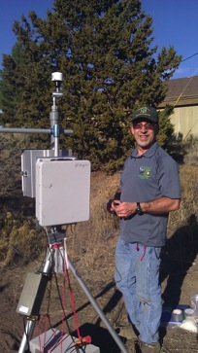
Bend SO E-Sampler K18099

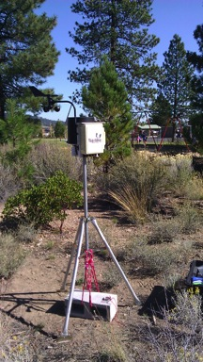
Miller Elementary FERA_WX7

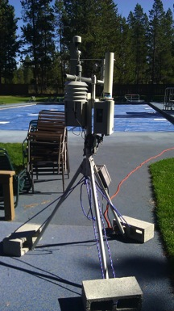
Sunriver E-Sampler Smoke16

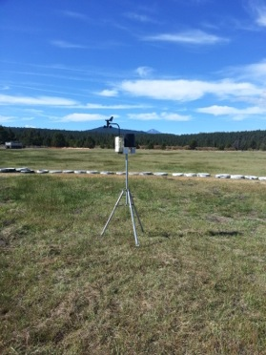
Sunriver Airport FERA_WX10

Bend Field Notes – 10/22-23/2014 – Check monitors and download data, install Smoke 65 at Lava Falls

WX3 – Cascade Academy
- in local (PDT) time, not GMT

The data shuttle reset all times to PDT, therefore went back to each station and reset to GMT.

Smoke K18099 at Bend SO Office
- Time was 9 hrs ahead instead of 7 hrs ahead, therefore reset to 7 hrs ahead of PDT so that it was correctly at GMT.
- Could not download the data – multiple tries

WX10 – Met station at Sunriver airport
- off by 2 hrs. I think it was only 5 hrs ahead of PDT, not 7 hrs.

Smoke 16 - Sunriver
- Could not get rid of zero calibrate error
- Data with the alarm code of 1 indicates this
- Blew air in
- Called Randy
- Lost power 2 days earlier which drained the battery
- Installed battery from Smoke 65

Lots of rain.

Smoke 65 – Lava Falls
- Installed at Lava Falls
- Put battery in from Smoke 16 and hopefully it charges
- Colin Wills – Arnold Inspection District, 541-639-1571, 541-382-7664 (office) cwils@bendbroadband.com, 19604 Buck Canyon Rd
- http://www.arnoldirrigationdistrict.com/index.php/contact-us/
- Lat = 43 deg 59.166 min
- Lon = -121 deg 23.901 min

Project Research Questions/Discussion
- Met station correlations – RAWS and ours
  - Rick has the RAWS list
- Burn day analysis
  - How many and when do they occur
  - Multiple year analysis
  - RAWS and WRF
- Look at previous intrusions
  - Apply 3hr and 8hr averages to existing “intrusions”
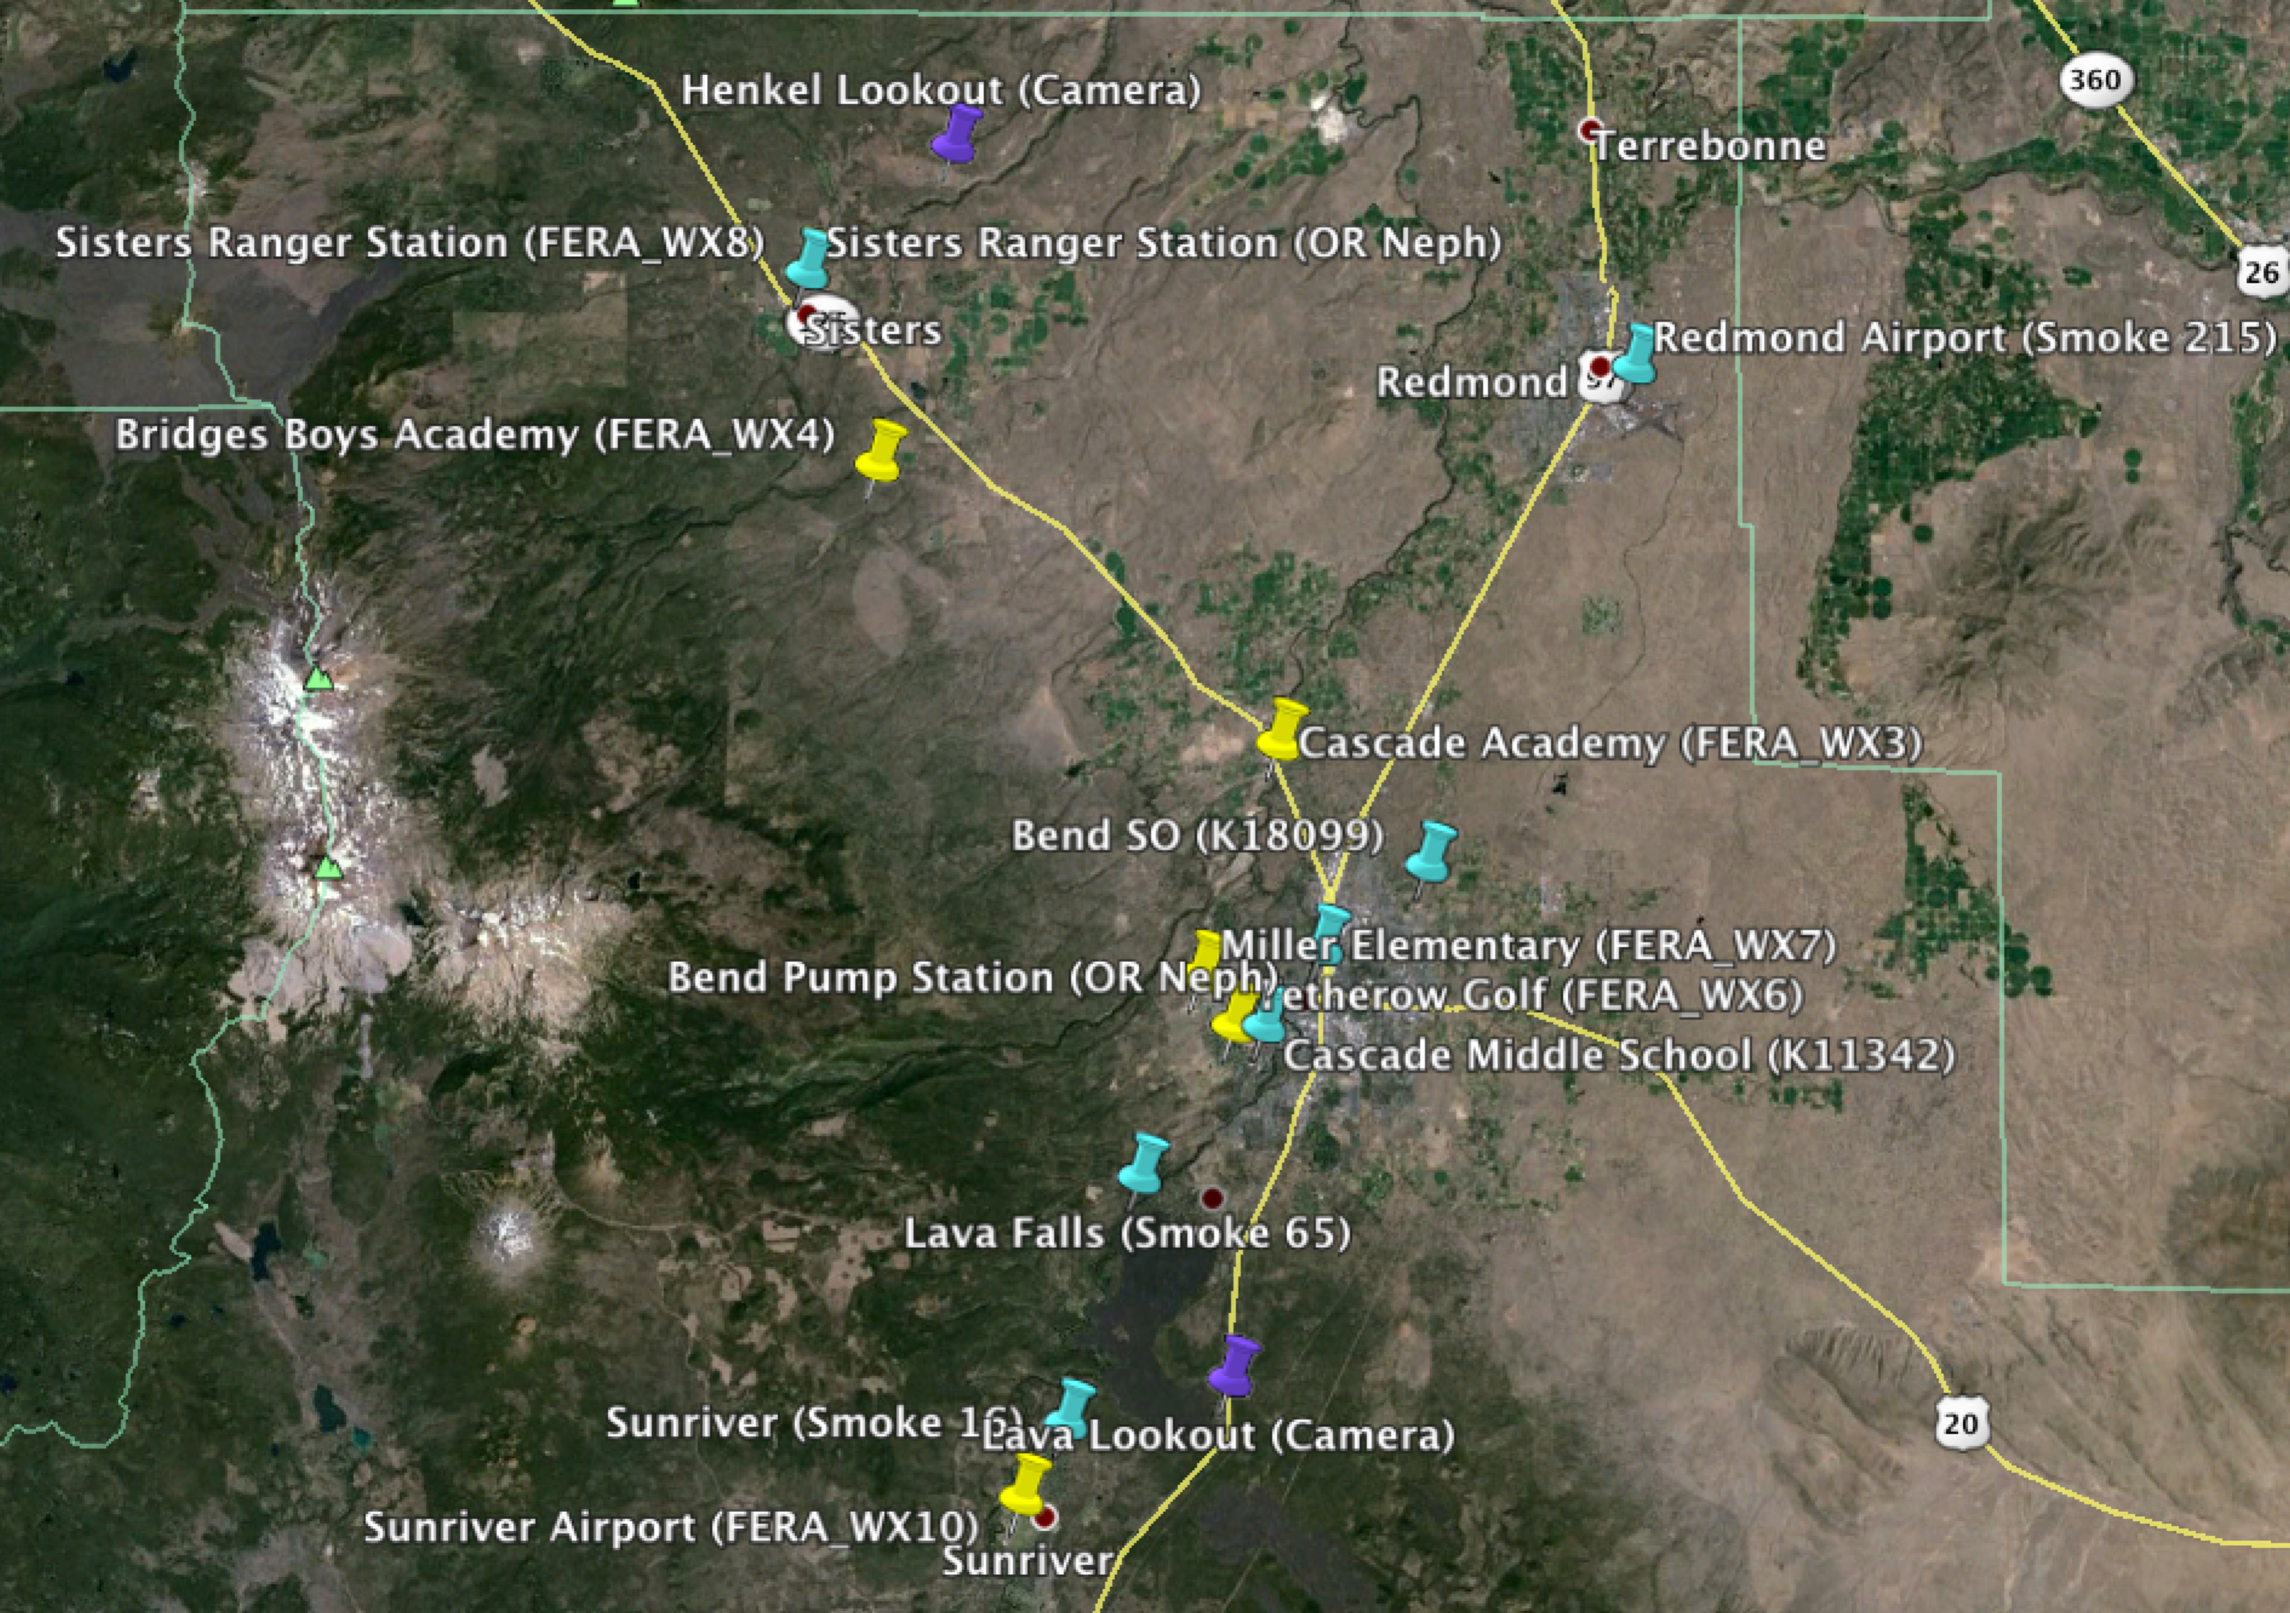
  - Do they go over Moderate?
- Rick summarized things really great in one of his emails.
Figure 1. E-Sampler and Oregon nephelometer locations (blue pins), meteorological station locations (yellow pins), and camera locations (purple pins) for the Bend Rx burning study.

