Smoke Management Meteorology
Brian Potter, Miriam Rorig, and Sue A. Ferguson

Once smoke enters the atmosphere, its concentration at any one place and time depends on mechanisms of transport and dispersion. By transport, we mean whatever carries a plume vertically or horizontally in the atmosphere. Vertical transport is controlled by the buoyancy of the smoke plume and stability of the atmosphere. Horizontal transport is controlled by wind. The larger the volume of space that smoke is allowed to enter and the farther it can be transported, the more disperse and less concentrated it will become. To begin understanding atmospheric stability and winds that control transport and dispersion, we begin with a few elementary concepts. Definitions for many of the technical terms used in this chapter can be found on the National Weather Service website (U.S. Department of Commerce, National Oceanographic and Atmospheric Administration, National Weather Service 2009).

Temperature, pressure and height
A comment about units is necessary here. While this chapter uses Imperial measures, such as feet, pounds, and degrees Fahrenheit whenever possible, this is not feasible in the discussion of profiles, soundings, and atmospheric pressure. These are always provided in units of meters, degrees Celsius, and millibars, and so the reader will eventually need to become familiar with these units. For the present discussion, the main focus is on the visual interpretation of the data and the units are of minimal importance.
Atmospheric pressure is the weight of the atmosphere over a horizontal unit area. At higher altitudes there is less atmosphere above the unit area, so pressure is lower. Sea level pressure (the surface or ground-level pressure at locations at sea level) is generally between 970 and 1030 millibars (mb). Typical surface pressures in Denver, roughly 5000 ft above sea level, are about 150 mb lower because there is less atmosphere above it. Low sea level pressure corresponds to frontal passages and hurricanes, while high sea level pressure commonly produces clear skies and heat (cold) waves in summer (winter).

Atmospheric pressure decreases with increasing height, and as a result, a bubble (commonly called a parcel) of air that rises will expand. If no energy is added to or removed from the parcel, this is called an adiabatic process. Air expanding adiabatically cools, and air adiabatically contracting warms. Perfectly adiabatic ascent (descent) results in a temperature decrease (increase) of 5.5 °F per 1000 ft of ascent. The rate at which the atmosphere cools with increasing height is called the lapse rate, and this particular rate of cooling is referred to as the dry adiabatic lapse rate (DALR). The DALR is illustrated by the dry adiabat lines on a skew-T diagram (see fig. 8 in the skew-T section below).

Adiabatic movement is an idealized concept and in general, movement of air in the atmosphere is not truly adiabatic. Parcels mix with air around them, friction adds or removes energy, and absorption or emission of infrared radiation adds or removes energy. Because of these processes, the actual dry lapse rate in the atmosphere is usually closer to 3.5 °F per 1000 ft, rather than the DALR.

As a parcel of air rises, it can cool to the point that water vapor condenses into droplets (the maximum possible amount of water vapor decreases with temperature). Condensation releases stored energy (known as latent heat) into the parcel of air, partially offsetting the adiabatic cooling. For air in the lower 5000 to 10,000 ft of the atmosphere, this offsetting energy reduces the parcel’s lapse rate to approximately 3 °F per 1000 ft. The lapse rate for saturated (moist) air is called the saturated adiabatic lapse rate (SALR) or moist adiabatic lapse rate (MALR). Air that is initially drier has less moisture to release heat and offset cooling, and so may have a SALR close to the DALR.

Stability
Stability is a measure of how strongly the atmosphere inhibits or supports vertical movement of air. When the atmosphere is stable, a small movement or perturbation (up or down) of a parcel results in forces that push it back towards its original state. In an unstable atmosphere such a change is amplified or increased by the forces involved, and the parcel will continue moving in the direction of the perturbation. Neutral stability is the case when the small change is neither counteracted nor enhanced, and the parcel remains in its new position. A parcel of air that has the same temperature as the air around it is said to be at its thermodynamic equilibrium level, often just referred to as the equilibrium level.

The key to determining atmospheric stability lies in the lapse rates discussed earlier. A parcel of air that is warmer than the air around it is less dense and so it will start to rise. A parcel cooler than its environment will similarly sink. If the parcel rises, it expands and cools at the DALR, while the surrounding environmental temperature, pressure, and density all decrease. Consider a dry parcel warmer than its environment at some starting height. It will rise, and as it does so it will cool at the DALR. If the environment cools more slowly with increasing height, the parcel will eventually be the same temperature as the environment. If it rises any farther, it will be colder and denser than its environment. In this case the environment is stable to movement of the air parcel. If the environment cools more rapidly with height than the DALR, the parcel will become increasingly warmer than the environment and will continue to rise. This environment is unstable to movement of the air parcel (box 1).

Stability is important because it determines how high smoke will rise in the absence of wind. In a stable atmosphere, smoke released near the ground will remain near the ground. The heat energy the smoke possesses from the fire may allow it to rise some distance before reaching its equilibrium level, but whatever height the smoke reaches, it will typically have a clearly defined, smooth, uniform top. High stability generally impedes winds, while low stability or any instability may allow wind to influence the smoke dispersion and produce more diffuse edges to the smoke plume.

Box 1—Application of lapse rates
Consider an environment with a lapse rate of 4 °F per 1000 ft. A parcel of air that starts at the same temperature as the environment and rises 100 ft will cool at the DALR, thus cooling 0.55 °F. The environment, however, is only 0.4 °F cooler at this height, and the parcel is now 0.15 °F colder than the surrounding air. The parcel will be denser, and will descend towards its starting height because the atmosphere is stable. This air was initially at its equilibrium level.
Suppose the parcel had started at 70 °F, and the environmental temperature around it was initially 69.4 °F. After rising 100 ft, the parcel would be 69.45 °F (70.0 °F ˗ 0.55 °F = 69.45 °F) in an environment at 69 °F, and would continue to rise because it is warmer than the surrounding air. But if the parcel rose 400 ft, it would cool by 2.2 °F (0.55 °F/100 ft × 400 ft) to 67.8 °F. The environment, 400 ft above where the parcel started, is 1.6 °F cooler than at the starting height (0.4 °F/100 ft, × 400 ft), or 67.8 °F. The parcel and environment are now at the same temperature, and if the parcel rises any farther it will be colder than the environment. This air parcel has reached its equilibrium level. If the parcel of air is smoke from a fire, that smoke will reach this equilibrium level and remain there.

A similar process applies to downward displacement, or displacement of a parcel that is initially colder than its environment. If a parcel is saturated with respect to water, then the appropriate SALR would be used in the calculations and comparison. A parcel could also start out unsaturated, and rise to a height where it is cooled to saturation. In this case, the DALR applies first, and the SALR once saturation is reached.

Inversions
Typically temperature decreases with height (with warmer temperatures near the ground). Sometimes, however, the environment is cooler near the ground than it is above, a situation known as an inversion. A surface- or surface-based inversion extends from the ground upward, to the level where the air temperature resumes its normal decrease with height. If the bottom of the inversion layer is elevated, above the ground, it is an upper-level inversion. There are several causes of inversions, but regardless of the cause, an inversion is extremely stable and has the effect of trapping smoke near the ground. Inversions vary in how high they reach (their depth), and their duration. They can be enhanced or diminished by the terrain. There are three types of surface inversions: radiation, marine, and frontal. Upper-level inversions are almost always subsidence inversions. The various types of inversions can interact, and there can be multiple inversion layers in the atmosphere at a given place and time.

Radiation Inversions
A radiation inversion develops on calm, clear nights when the heat radiated from the ground at night passes through the atmosphere relatively easily. This cools the ground, which in turn cools the air next to it. As the night continues, the air at the base of the inversion cools the most, and the depth of the inversion grows. If dew or fog begins to form, the rate of cooling decreases. When the sun rises, it begins to heat the ground and “burn away” the inversion from the bottom. If the inversion trapped heavy smoke, or if thick fog formed, less sunlight will penetrate and the inversion will persist later into the day.

Marine Inversions
Marine inversions occur when cool marine air flows inland. They are most common during the summer, when the sea breeze develops more strongly, and along the west coast where prevailing winds blow onshore. Cooler, denser marine air moving inland slides underneath warmer air that was heated over the ground. As heating from the sun weakens later in the day, the inversion can intensify (just as a radiation inversion would do). There is usually only a light breeze during the onset of a marine inversion. Marine inversions usually break up the same way a radiation inversion breaks up, with the sun heating the ground and the ground then heating the air next to it. Because the marine air is relatively moist, marine inversions often result in morning fog that delays break-up.

Frontal Inversions
Frontal inversions result when a cold or warm front moves into an area, and can occur at any time of the day or night. Arrival of a cold front (fig. 1a) results in cooler air sliding underneath warm air. A cold frontal inversion increases in depth, as more cold air moves in and lifts the warm air farther from the surface. Cold frontal inversions are often accompanied by moderate to strong winds.

Warm frontal inversions precede the arrival of the warm front at the ground. The approaching warm air rides up over cooler air in a region, producing an inversion that becomes weaker and shallower as the front approaches (fig. 1b). The winds associated with warm fronts are usually light to moderate.
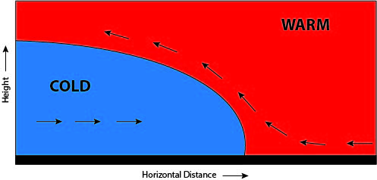
(a)
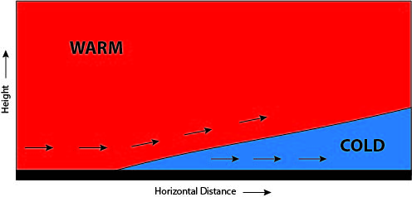
(b)
Figure 1—Vertical cross section illustrations of (a) an inversion created by a cold front sliding (left to right) under a warm front, and (b) an inversion resulting from a warm front moving (left to right) over a cold front (not to scale.) Typically winds associated with cold fronts are stronger than warm frontal winds.

Subsidence Inversions
Large regional (also called synoptic-scale) high pressure systems extending several thousands of feet above the surface produce areas of sinking (subsiding) air, and that sinking air warms adiabatically. Fig. 2 shows a high pressure system located over Arizona and New Mexico. Because the subsiding air is warming, it becomes warmer than the air below it and produces an inversion. The inversion forms 3000 to 5000 feet above the ground, and descends a few hundred feet each day. The subsidence is very slow, and can persist for as long as five days. Eventually, it moves close enough to the ground that surface-based mixing (see Mixing Height section below) can dissipate it.
Figure 2—Synoptic upper-level map showing a high pressure system over Arizona and New Mexico. Solid lines indicate the height above sea level (in tens of meters) where pressure is 500 mb.

Inversion Interactions with Terrain
Any surface-based inversion can trap smoke close to the ground, but this can be especially problematic in valleys and other low-lying areas. Inversions in valleys cause tremendous problems for those who manage long-duration fires that continue into the night. Figure 3 shows smoke, caught under a valley inversion, being transported by down-valley winds in the early morning.
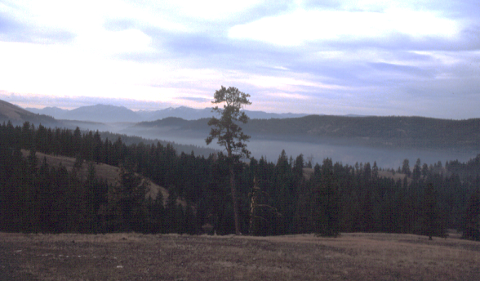
Figure 3—Smoke flowing out of a mountain valley with down-slope winds during the early morning. (Photo by Roger Ottmar)
In areas of high topographic complexity, an upper-level inversion can complicate smoke management because the inversion may be close to the ground in high elevation regions. Because of this, smoke may rise well above ground at the site of a fire, but be trapped near the ground at higher elevations downwind. Alternatively, fires burning for long periods may spread to higher elevations and potentially rise above an upper-level or surface inversion. For these reasons, smoke management in areas of complex topography during weather prone to inversions requires great attention to details of terrain, wind, and vertical temperature structure.

Mixing Height
Mixing height, also called mixing depth, is the height (above ground level) in which instability and mechanical mixing due to winds and friction create near-constant vertical distributions of moisture and particulate concentrations, and an approximately adiabatic lapse rate. Low mixing heights mean that the air is generally stagnant with very little vertical motion; pollutants usually are trapped near the ground. High mixing heights allow vertical mixing within a deep layer of the atmosphere and more efficient dispersion of pollutants. The depth of the mixed layer depends on complex interactions between the ground surface and the atmosphere. At times, it is possible to estimate the mixing height by noting the tops of cumulus clouds. Similarly, the presence of an upper-level inversion may be inferred from a layer of stratus clouds (fig. 4).
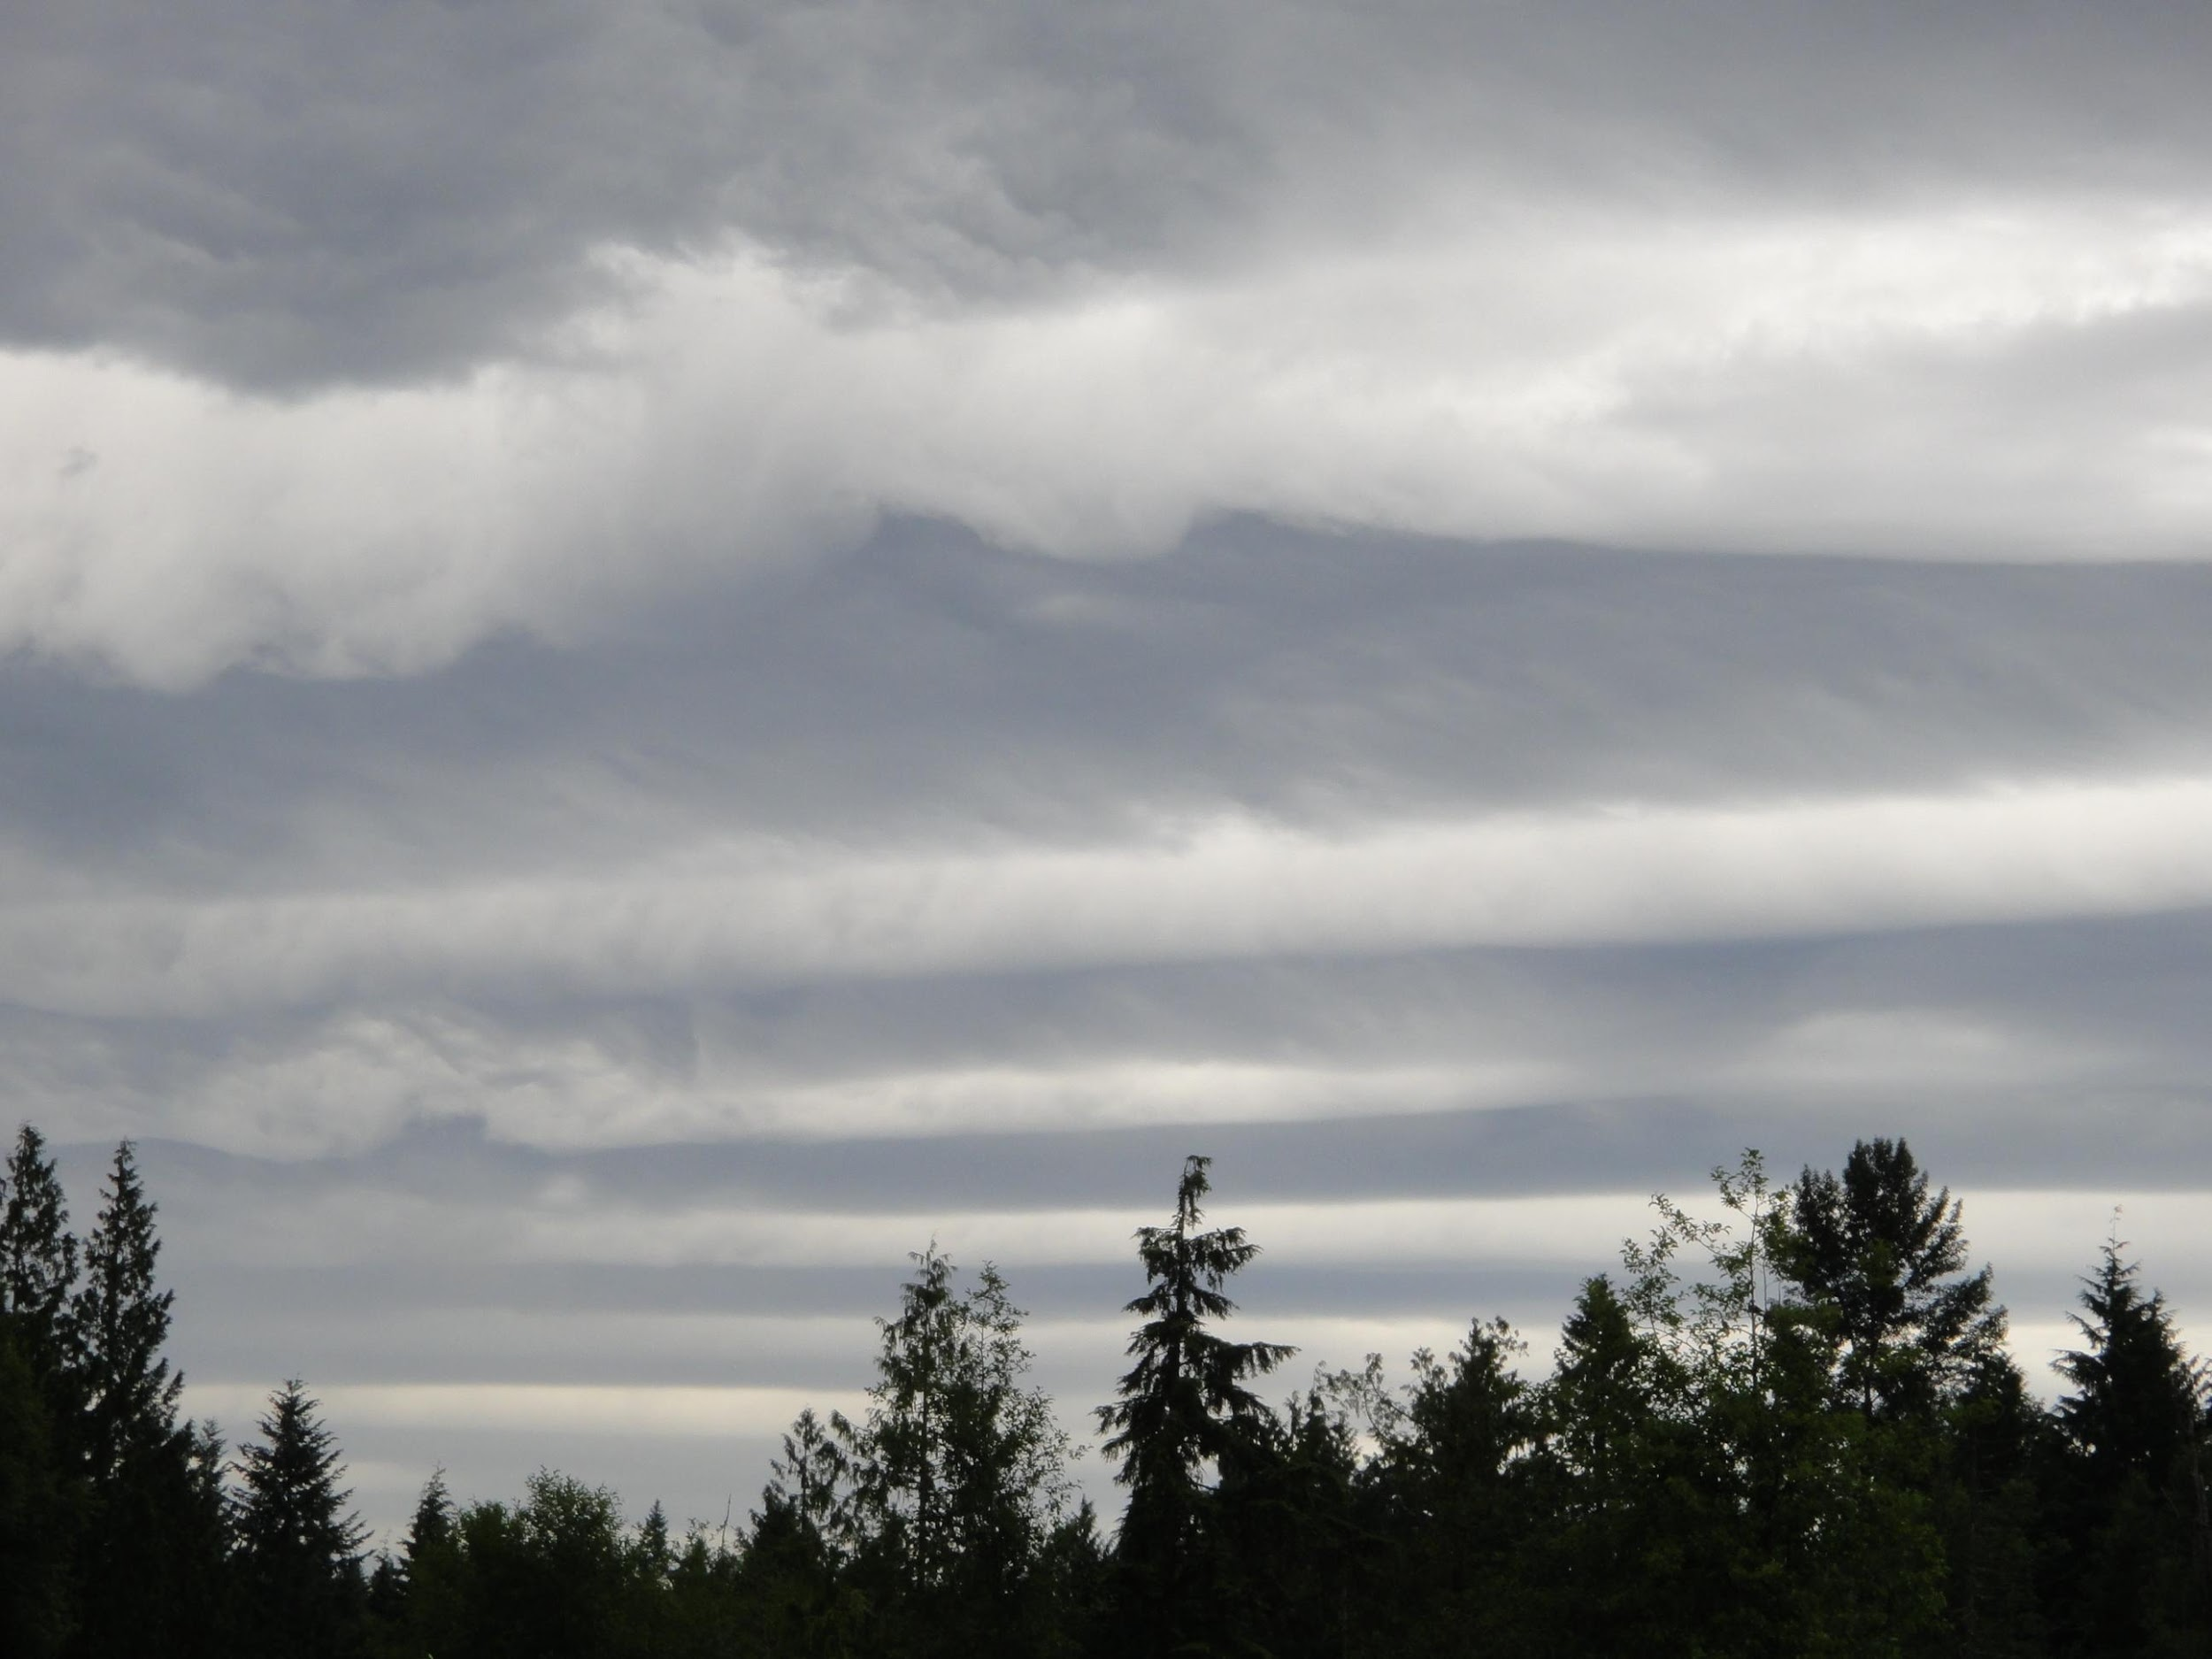

Figure 4—Layer of stratus clouds. (Photo by Miriam Rorig)

Mixing heights are sometimes used to estimate how high smoke will rise, and therefore, the speed and direction of the winds that will disperse the smoke. The actual rise of a smoke plume, however, involves complex interactions between the temperature and wind profiles of the environment and the temperature and moisture characteristics of the smoke from the fire. Therefore, mixing height provides only an initial estimate of plume height. The more vigorously a fire is burning, the stronger an inversion must be to stop the air rising in the fire’s smoke column. When a plume loses the intense energy source of a vigorous fire, atmospheric stability may dominate that energy and serve to prevent smoke from rising. The combination of decreased fire intensity and increased low-level atmospheric stability at night traps almost all smoke near the ground at night.
Holzworth (1972) created a climatology of mixing heights, approximating them by using equilibrium heights (box 2). Mixing heights usually are lowest late at night or early in the morning, and highest during middle to late afternoon. This daily pattern often causes smoke to concentrate in basins and valleys during the morning and disperse aloft in the afternoon. Average morning mixing heights range from about 980 ft to more than 2900 ft above ground level. The highest morning mixing heights occur in coastal areas that are influenced by the moist marine air and cloudiness that inhibit nighttime radiative cooling. Average afternoon mixing heights are typically higher than morning heights and vary from less than ~2,000 ft to over ~4,600 ft above ground level. The lowest afternoon mixing heights occur during winter and along the coasts. Mixing heights vary considerably between locations and from day to day. Detailed maps and statistics related to historic mixing heights in the United States are available in Ferguson and others (2003).
Numerical meteorological models provide calculated depths for the planetary boundary layer (PBL), closely related to the mixing depth (box 2). These calculations are more detailed than those involved in determining thermodynamic equilibrium height, because they consider wind as well as buoyancy. While these are useful for anticipating poor ventilation conditions, there are limitations in the way PBL height is computed in numerical models, therefore model-generated PBL heights may be less reliable than a human-generated forecast.

Box 2—Mixing height, equilibrium height, and planetary boundary layer

These three terms describe related concepts. They are, however, not identical.

(Thermodynamic) equilibrium height: The height at which a parcel of air has the same temperature as its surrounding environment after rising or descending (dry or moist) adiabatically. This depends only on the temperature profile of the environment and the temperature and moisture content of the parcel.

Mixing height: The height to which pollution (or water vapor) from the ground mixes due to the combined effects of thermal buoyancy and mechanical mixing. This can be higher or lower than the equilibrium height. The key distinction is that mixing height recognizes the effects of wind and turbulence, while equilibrium height is based solely on temperature considerations. The mixed layer is the layer of the atmosphere extending from the ground up to the mixing height.

Planetary boundary layer (PBL): The layer of the atmosphere in contact with the earth. It is the layer where the turbulence and radiative processes related to the ground drive temperature and wind changes. It extends from the ground, through the mixed layer, to a capping inversion during the day. At night, it includes the stable layer that forms near the ground, as well as a residual layer up to the capping inversion. This is an idealized concept, easier to describe than to identify in reality. It is a measure predicted by numerical weather models, but is difficult to use as an estimate of how high the smoke will actually be lofted.

Diurnal Cycles
The diurnal cycle in atmospheric stability and mixing is an extremely important consideration for smoke management. Even if burning operations will be completed during the daytime, any residual smoldering or smoke near the ground will be affected by nighttime atmospheric conditions. While some aspects of the diurnal cycle appeared above, this section focuses specifically on the cycle and its importance to smoke management (fig. 5). In the absence of strong winds (an assumption that will apply to the rest of this discussion), calm conditions and a nocturnal surface inversion characterize early morning conditions. As the sunlight heats the ground, temperatures there begin to increase. This creates a weak unstable layer near the ground, which begins to mix with air above it. Mixing and energy re-radiated from the heated ground gradually erode the inversion from the bottom up. This bottom-up process applies even in foggy situations, but can be substantially slowed.

Under moderate sunlight and with damp or heavily vegetated ground, the surface unstable layer remains shallow. When sunlight is intense and the ground heats rapidly, usually due to dry or barren ground, the unstable layer can grow to become tens to hundreds of meters deep as the stabilizing effect of turbulent mixing struggles to keep up with the destabilizing effect of surface heating. This mixing can bring stronger winds down from above, further reducing the surface heating effect. The net result is more wind at the ground, as well as more turbulence. Smoke produced by the head of the fire during the day when this is occurring will rise upward to the base of any remaining inversion. Less buoyant smoke, from flanks or smoldering, will be mixed by the turbulence and gradually fill the mixed layer downwind of the fire.

As the sun lowers toward the horizon again, surface heating will decrease and surface cooling will once again begin to create a stable surface layer. Smoke near the ground will remain there, unable to rise, but smoke that had already risen will be cut off from returning to the surface. Winds, too, become isolated above the growing inversion and diminish at the ground. Additional smoke produced during the night will remain at the ground and near the fire, as stability and low winds prevent vertical and horizontal movement, respectively.
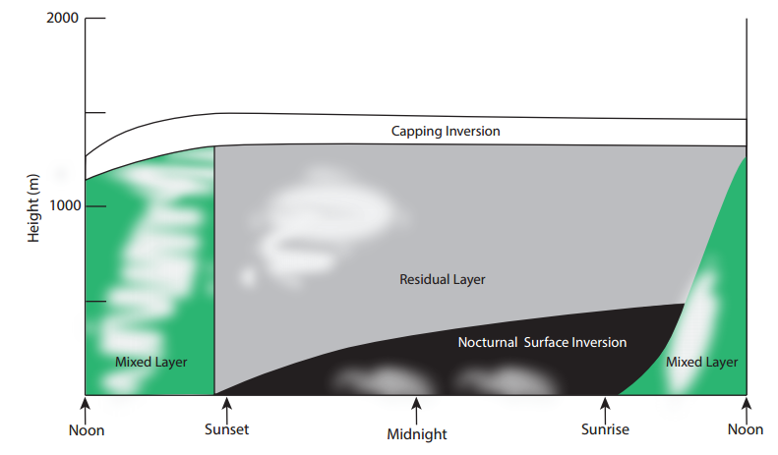Figure 5—Illustration of the mixed layer diurnal cycle. Black indicates the nocturnal inversion, green shows the mixed layer, and the white band is the capping inversion atop the mixed layer. White puffs illustrate the distribution of smoke at various times. Smoke emitted during the day disperses through the mixed layer as it exists at that time, and may linger in the residual layer at night. Smoke emitted at night will remain in the surface inversion layer.

Plume Characteristics

The key concern with smoke is whether it rises above the ground in a plume, or stays close to the ground. If it rises, then one needs to consider whether it is likely to return to the ground farther away. Any time the atmosphere near the ground is stable, whether or not it is so stable that an inversion is present, smoke from less intense parts of the fire will tend to remain close to the surface, producing the highest concentrations of smoke at the ground. When the atmosphere is neutrally stable or unstable, the smoke can rise freely, and disperse through a deeper layer of the atmosphere. The greater vertical dispersion reduces concentrations near the ground. When smoke rises to the base of an inversion, and there is mixing below—typical daytime conditions for burning—that mixing has the potential to bring smoke back towards the ground. This can create smoke impacts well downwind of the burn, even when there is no detectable smoke at the ground immediately downwind of the fire.

Soundings and Profiles
A sounding is a series of measurements of the temperature, humidity, pressure, and wind speed and direction in a vertical column of the atmosphere. The most common source for these measurements is weather balloons carrying radiosondes. These are small electronic instruments that transmit those measured variables back to a ground-based receiver. Radiosondes are released by the National Weather Service, twice a day, across the United States. Technology has made it possible, in recent years, for other organizations or individuals to release their own radiosondes at sites and times of particular interest. For example, incident meteorologists on wildfires often use this capability to measure atmospheric stability and winds aloft at the location of the fire. The measurements from a radiosonde, taken together, constitute the vertical profile of the atmosphere at that time and place—though “sounding” and “raob” (short for radiosonde observation) are also commonly used to refer to the profile. An atmospheric profile can be presented as a series of numerical values for the measured properties at various heights, or it can be presented graphically. A graphical profile is generally much easier to understand or analyze. Both graphical and text-based soundings are readily available from various sources on the internet. The following section explains graphical soundings, followed by several examples of their use in smoke management.

Because upper-air observations are not always available at the time and/or location of the fire, Pasquill (1961, 1974) developed a scheme to estimate stability of atmospheric layers from ground-based observations. While the use of this scheme has been largely replaced by more widely available ventilation forecasts calculated from weather models, the basic principle is that nighttime conditions are typically less windy and, if there are few or no clouds, more stable, making it more likely that existing smoke will be trapped near the surface. An objective way of determining stability classification is shown in Lavdas (1986) and Lavdas (1997). For further examples see Chapter 4.4 Practical Tools: Meteorology and Simple Models for Predicting Smoke Movement and Potential Smoke Effects.

The Skew-T Diagram
A skew-T diagram is a useful tool for quickly visualizing soundings and the vertical locations of inversions, allowing the fire practitioner to estimate how high smoke will loft. Skew-T diagrams contain a great deal of information, and require some practice to understand and use. This section breaks them down into their components and provides examples. There are several types of diagrams used to plot an atmospheric profile.

The most common in the United States is the skew-T (sometimes called skew-T log-p) diagram. This consists of grids of lines showing temperature, pressure, and moisture, with winds indicated to the side of the grid. Fig. 6 shows a blank skew-T diagram. The first set of lines to note on a skew-T plot are the horizontal lines representing constant pressure. Typically when data are shown on the plot, there will be physical height values noted beside the pressures, or on the opposite side of the graph, to indicate the height where that pressure was measured. Some of these lines are shown in black. Lines indicating temperature run diagonally from lower left to upper right, with examples indicated in red on fig. 6. When a sounding indicates the temperature at a given pressure level, that is plotted on the diagram at the intersection of the appropriate temperature line and the appropriate pressure level. Figure 6 has a black dot (point A) plotted to indicate a temperature of -5 °C at a pressure of 800 mb. The collection of measured temperatures at various pressure levels is called the temperature trace, and on a skew-T diagram appears as a zig-zag line as temperature varies with height.
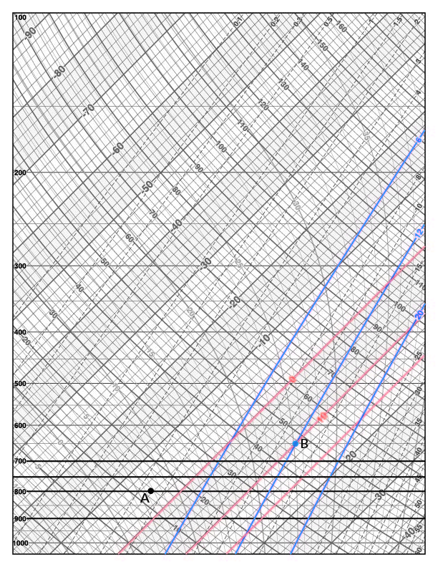
Figure 6—Skew-T chart. Horizontal lines indicate pressure levels. Solid lines running from lower left to upper right (examples in red) indicate temperature, dashed lines (examples in solid blue) indicate water vapor mixing ratio. The black dot (point A) and blue dot (point B) are examples of specific conditions, discussed in The Skew-T Diagram section.

One other set of lines runs lower-left to upper-right on a skew T, and those are lines of constant water vapor mixing ratio. Water vapor mixing ratio is the mass of water in a unit mass (1 kg) of air, usually expressed as grams per kilogram. It is an absolute measure of moisture in the air (unlike relative humidity, which changes with temperature). The water vapor lines on the skew-T are colored blue on fig. 6, and are steeper than the temperature lines. The moisture in a sounding can be expressed as mixing ratios or as dew point temperatures. When given as mixing ratios at stated pressure levels, the intersections of the lines are used analogous to the way temperature is plotted: the value is plotted where the stated mixing ratio line intersects the stated pressure. When given as dew point temperatures at stated levels, the values are again plotted where those temperature lines intersect the matching pressure lines. The blue dot (point B) at 650 mb on fig. 6 indicates air with a mixing ratio of 12 g/kg and a dew point temperature of 10 °C. Whether the data are provided as mixing ratios or dew point temperatures, the series of points at various levels are connected in a second zig-zag line on the chart, always to the left of the temperature trace. Figure 7 shows an actual sounding, with the moisture profile on the left and the temperature profile on the right.
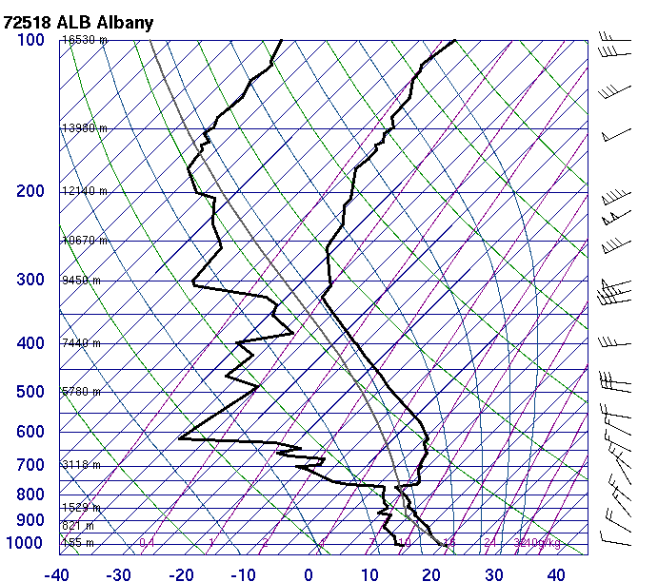
Figure 7—Example of a sounding, showing observations for 00 UTC August 28, 2015 at Albany, NY. The heavy black line on the left indicates observed dew point temperatures, the heavy black line on the right indicates observed actual air temperatures. Winds are indicated by the arrows along the right side, with the barbs pointing toward the direction from which the wind is blowing.

The next important set of lines on the skew-T diagram are called the dry adiabats, gently curving lines running from lower right to upper left (examples shown in green on fig. 8.) These lines indicate how the temperature of a dry parcel of air would decrease as it rises to heights with lower pressures. These lines, in other words, show the DALR defined earlier. They are labelled with the temperature an air parcel would have if it was lowered dry adiabatically to 1000 mb. In
fig. 8, the green square (point A) indicates a parcel of air with a temperature of 15 °C at 1000 mb. The heavy line going up to the left is the dry adiabat from here, showing how this air would cool as it rose to 800 mb, with a final temperature there of just below ˗2 °C, the green “X” (point B) on the figure.

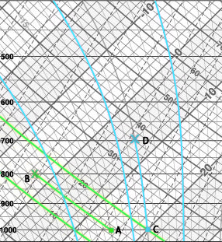

Figure 8—Skew-T diagram showing dry adiabats and saturated adiabats. Green lines from lower right to upper left indicate dry adiabatic lapse rate. Blue lines arcing upward and to the left are saturated adiabats. The short green line ending with a square (point A) and an X (point B) indicates the temperature change of a dry rising parcel, the short blue line ending with a square (point C) and an X (point D) indicates the temperature change of a saturated rising parcel.

The last set of lines on the skew-T diagram that are important for smoke management are the saturated adiabats. These lines rise almost vertically from the bottom of the graph, curving up to the left (examples highlighted in blue on fig. 7). They represent how the temperature of a saturated parcel of air would change as it rises in the atmosphere. On fig. 8, the blue square (point C) indicates a parcel of air starting at 1000 mb at 20 °C. If this air is saturated and rises to 700 mb, it will follow the blue line, up to the blue “X” (point D) where it will have a temperature of 16 °C. Note that if it had risen without saturation, along a dry adiabat, it would have a temperature of -8 °C (not shown). The difference between these temperatures indicates the heat released by condensing water vapor.

As noted earlier, winds are indicated as arrows along the right side of the skew-T plot (fig. 7). The feathers, also called barbs or tails, indicate the wind speed, and the end of the arrow with the barbs indicates the direction from which the wind is blowing (tails upwind, tip downwind.) The tip of the arrow is also set at the height of the wind measurement. A half-barb indicates 2.5 m/s, a full barb is 5 m/s, and a flag is 25 m/s. The wind speed is determined by adding the barbs on a given arrow. In fig. 7, the wind speed at 500 mb is 15 m/s, from the west; the winds at 800 mb are 7.5 m/s from the northwest.

Using a Skew-T Diagram
The power of a skew-T diagram becomes apparent when you see how easy it is to determine the stability of the atmosphere and the existence and locations of inversions (fig. 9). The time standard for observations across the globe is 12 UTC. Table 1 shows the conversion from UTC to local time for United States time zones. The temperature trace indicates an inversion at the ground. Surface temperature, just below 900 mb, is roughly 22 °C, while the temperature at 850 mb is almost 30 °C. Note that winds in this layer are very light.

There is also a very stable layer between 550 mb and 475 mb. The trace is more vertical than the dry adiabats here, but does not lean to the right with height to indicate an actual inversion. Smoke that penetrated the low level inversion would still have difficulty rising through this layer.
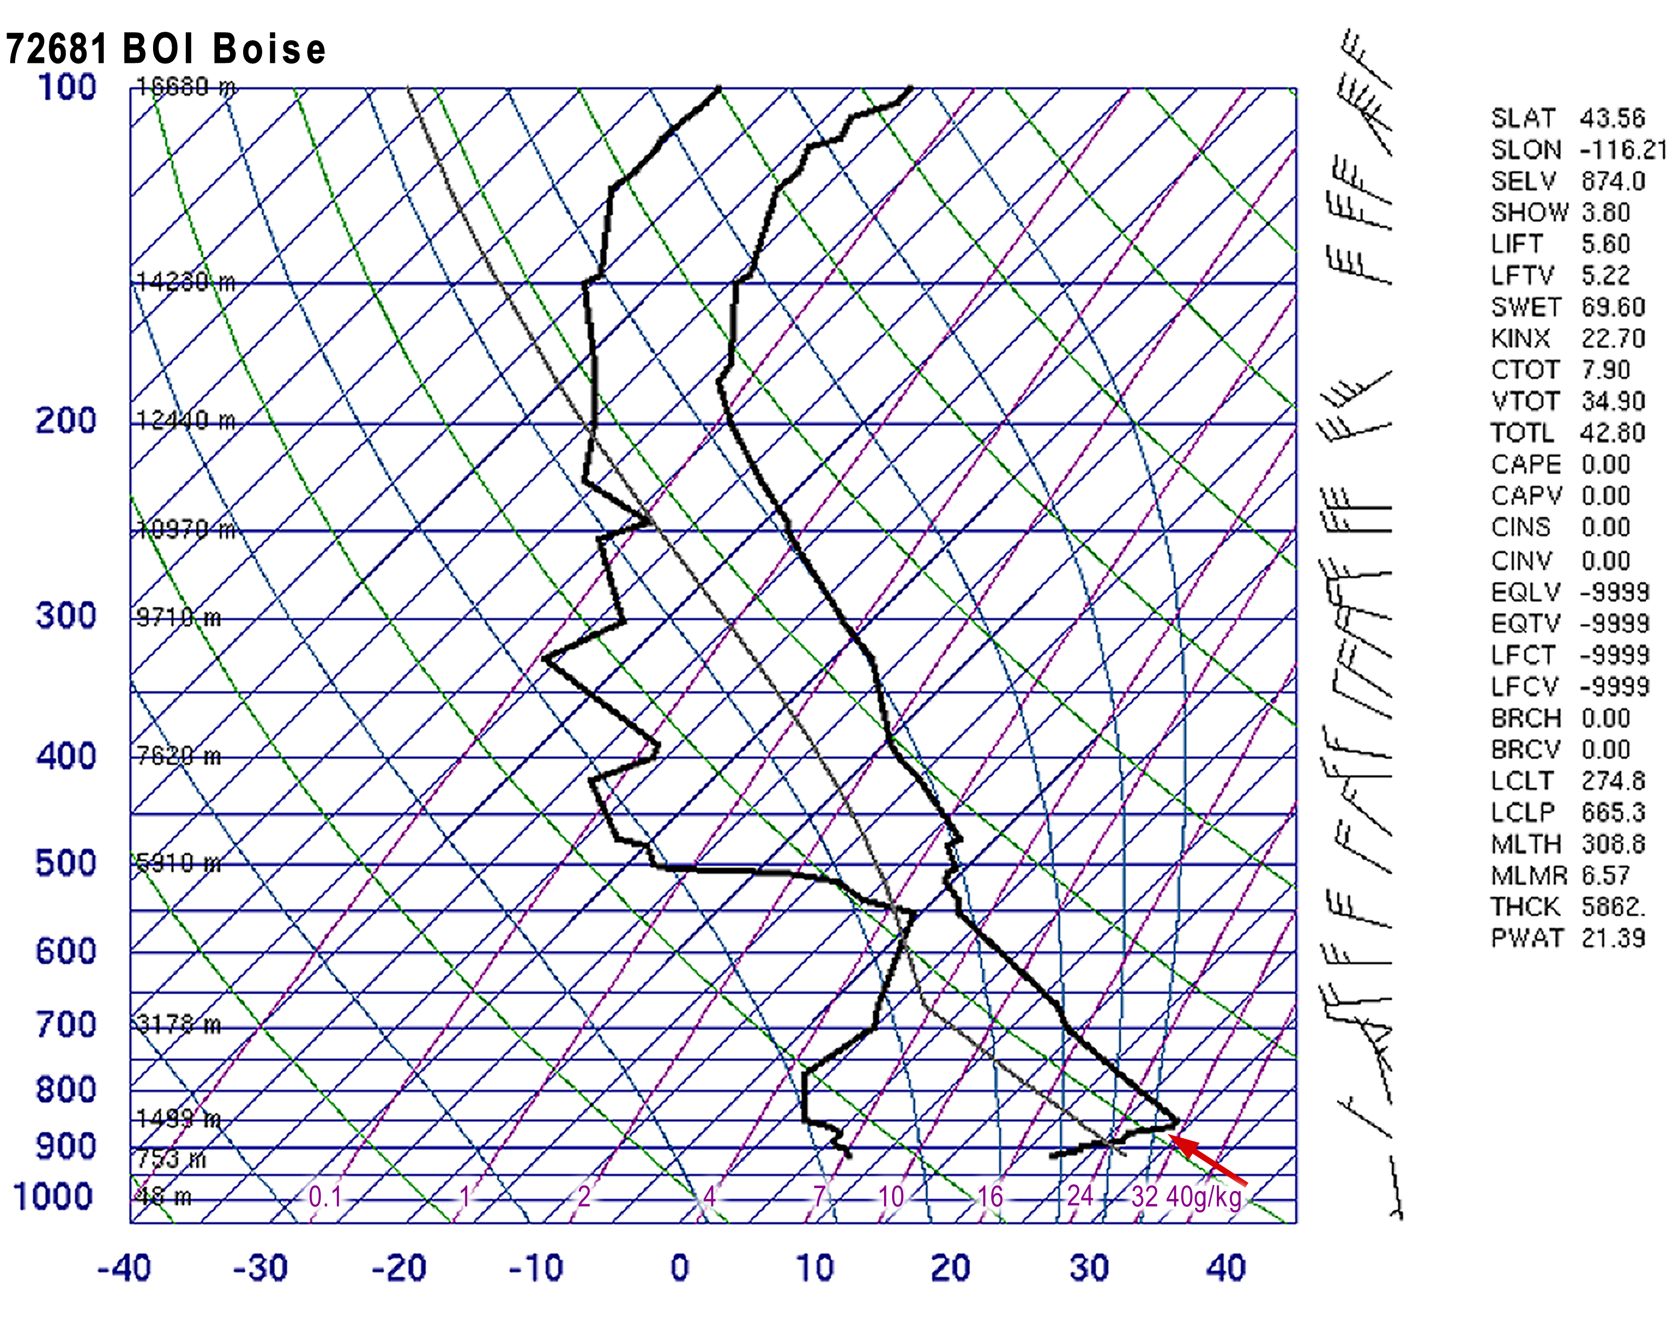
Figure 9—Observed profile for 12 UTC July 3, 2015 at Boise ID. The temperature trace—the heavy black line on the right—indicates an inversion exists at the ground (the red arrow points to the top of the ground-based inversion).

Figure 10 shows smoke capped by a surface-based inversion (as demonstrated by the temperature trace in fig. 9). Also visible is smoke pushing through the inversion, because of vigorous heat generated by the fire.

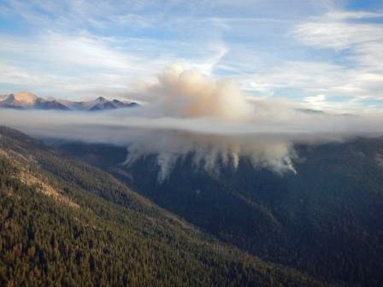
Figure 10—Example of a fire producing enough heat for the smoke plume to push through the ground-based inversion. (Photo from Sequoia and Kings Canyon National Park.)

Table 1—Conversion of Universal Time Coordinated (UTC) to local time for time zones in the United States
Time Zone | UTC | Local Time | Diff.
Eastern Standard Time | 0000 | 7:00 PM | -5
Eastern Daylight Time | 0000 | 8:00 PM | -4
Central Standard Time | 0000 | 6:00 PM | -6
Central Daylight Time | 0000 | 7:00 PM | -5
Mountain Standard Time | 0000 | 5:00 PM | -7
Mountain Daylight Time | 0000 | 6:00 PM | -6
Pacific Standard Time | 0000 | 4:00 PM | -8
Pacific Daylight Time | 0000 | 5:00 PM | -7
Alaska Standard Time | 0000 | 3:00 PM | -9
Alaska Daylight Time | 0000 | 4:00 PM | -8
Hawaii-Aleutian Standard Time | 0000 | 2:00 PM | -10

The sounding from 00 UTC August 20, 2015 at Tallahasee, FL is shown in fig. 11. The small separation between the dewpoint and temperature traces from the ground up to 700 mb indicates a humid environment. Smoke in this layer could readily turn to fog and produce visibility concerns. There is also an elevated inversion between 700 and 750 mb, indicated by the rightward tilt of the temperature trace with increasing height.
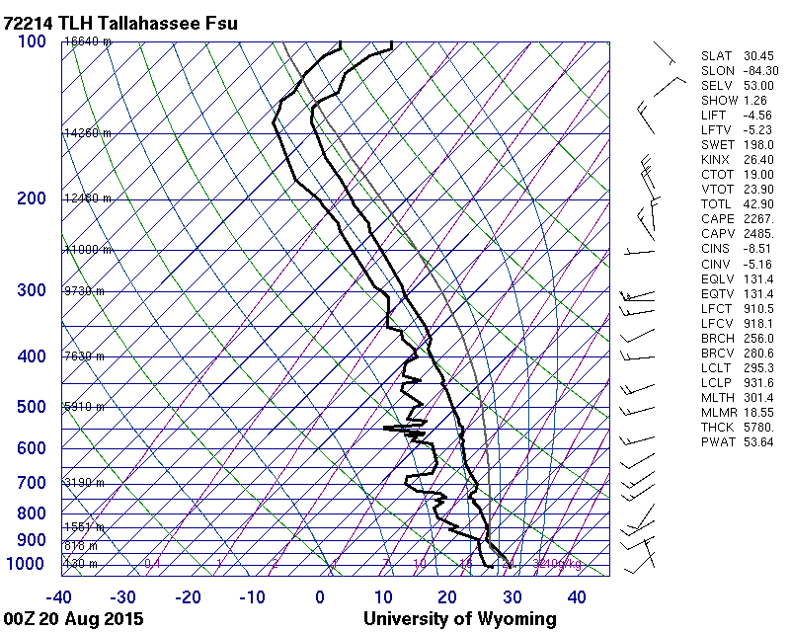

Figure 11—Observed profile for 00UTC August 20, 2015 at Tallahasee, FL. The small separation between the dewpoint and temperature traces from the ground up to 750 mb indicates a humid environment. There is also an elevated inversion between 700 and 750 mb, indicated by the rightward tilt of the temperature trace with increasing height (inside the red circle).

Figure 12 shows an example of an extremely well defined mixed layer. The temperature trace follows a dry adiabat, indicating neutral stability from the ground up to 800 mb. The dewpoint trace lies along a line of constant mixing ratio (6.4 g/kg) showing moisture is evenly distributed through this layer. Wind, shown by the arrows on the right edge, is less uniform. It is important to recognize that the mixed layer is never perfectly uniform. There are degrees of mixing, and the atmosphere is constantly changing. Figure 13 shows smoke within a well-mixed layer under an inversion.
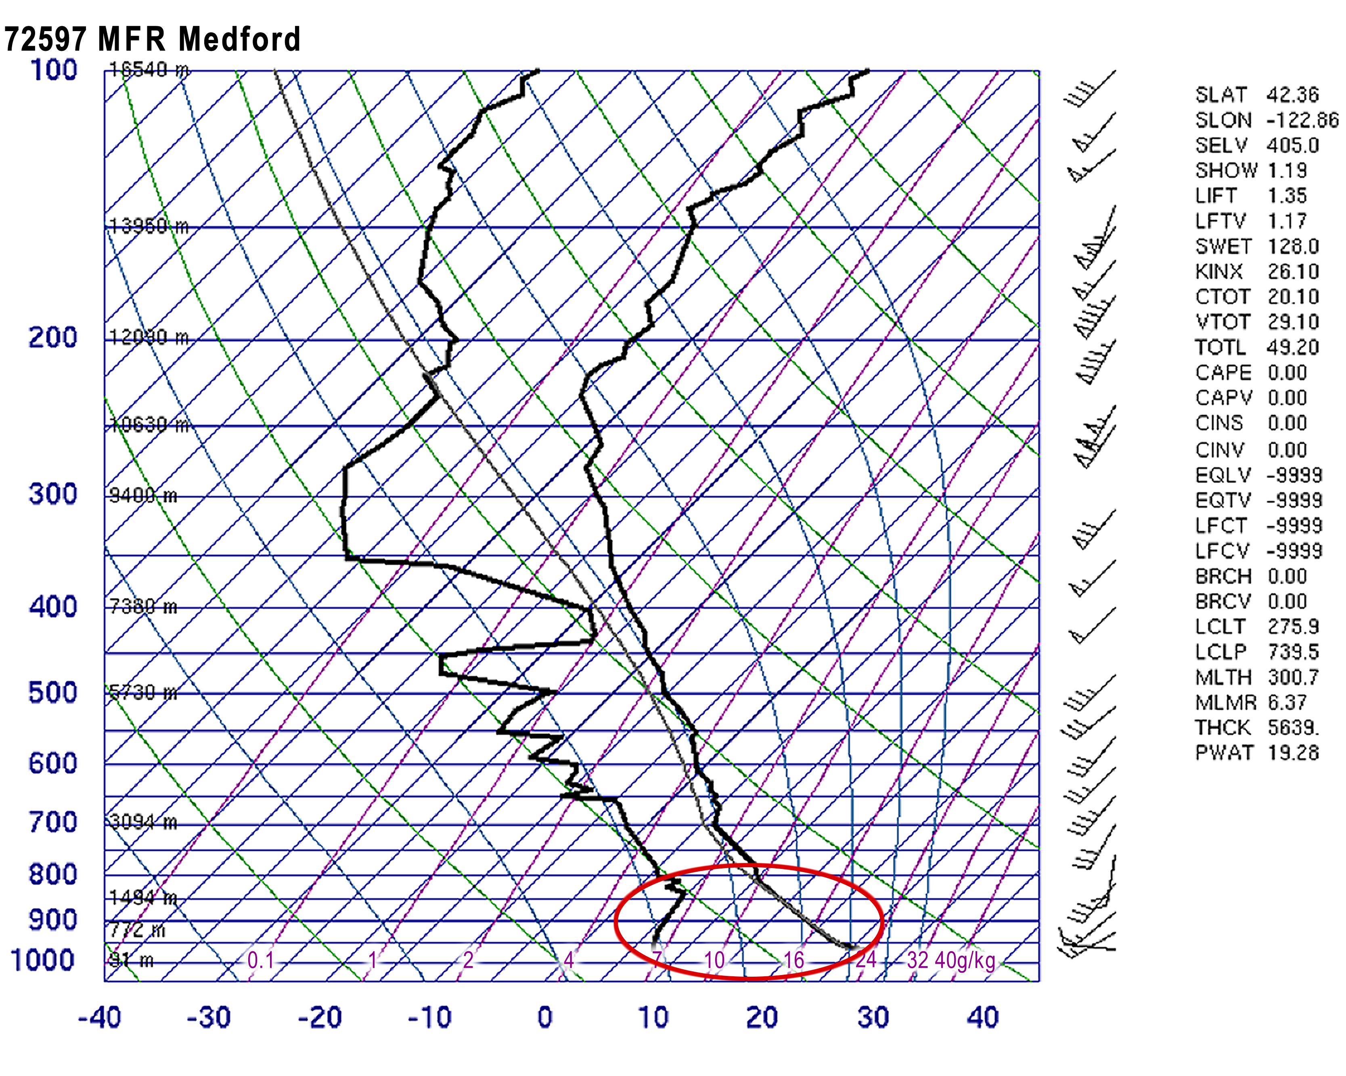Figure 12—Observed profile for 00 UTC August 30, 2015 at Medford, OR. Below 800 mb the temperature trace follows a dry adiabat, indicating a well-mixed layer with neutral stability (depicted by the temperature trace inside the red circle). The portion of the dewpoint trace inside the red circle also shows a constant mixing ratio (6.4 g/kg; the diagonal line next to and just to the right of the dewpoint trace has a mixing ratio value of 7 g/kg), indicating moisture is evenly distributed through this layer.

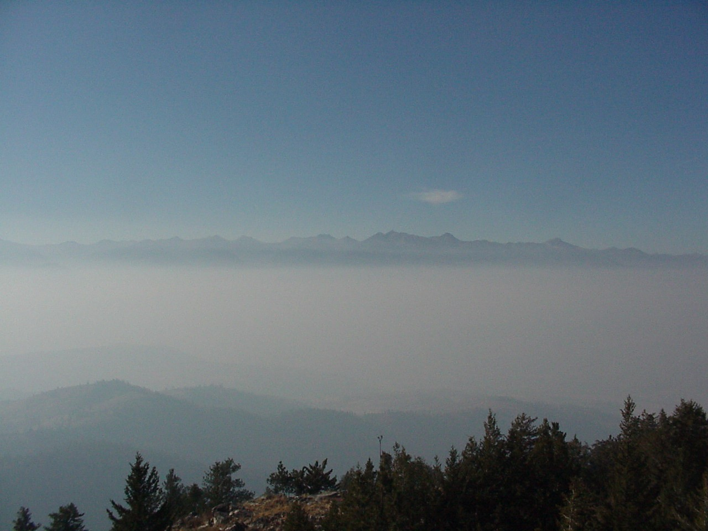
Figure 23—Example of smoke within a well-mixed, neutrally stable layer (as depicted by the temperature trace within the red circle in fig. 12) under an inversion. (Photo from Okanogan-Wenatchee National Forest).

Wind
While stability dominates the vertical movement of smoke in the fire’s plume, horizontal winds dictate the transport and dispersion of the smoke across the landscape. The stronger the wind, the more scattered particles become and the less concentrated they will be. Strong winds at the surface, however, can increase fire behavior, fuel consumption and associated emission rates. Also, significant surface winds may “lay-down” a plume, keeping smoke close to the ground for long distances.
Winds are influenced by many factors, such as regional-scale (also called synoptic-scale) weather systems or local features such as terrain and canopy cover. Often these factors interact with each other. Additionally, friction with the ground causes wind to slow down. Therefore, wind speed usually increases with height, causing a smoke column to gradually bend with height as it encounters increasingly strong winds. Mixing with surrounding air, increased by strong wind, also reduces the buoyancy of the rising smoke column and contributes to its bending. This pattern is complicated in regions of complex terrain, however, and it is common to find strong surface winds in mountain passes, saddles, and gorges as air is squeezed and funneled through gaps or over ridges. Forest clearings also allow surface winds to accelerate because surface friction is lower in a clearing than over a forest canopy.
Because smoke from different stages or sections of a fire rises to different levels of the atmosphere, it is important to know wind speed and direction at several different heights. For example, nighttime smoldering responds to surface winds whereas daytime smoke from the ignition and flaming phase of a fire will respond to upper-level winds. Depending on the buoyancy of the smoke and stability of the atmosphere, winds that influence upper-level smoke trajectories may be from just above a forest canopy to 10,000 feet (about 3,000 meters) or higher. Because flaming combustion can create strong vertical motion, most smoke from flaming portions of a fire will be carried to at least the top of the mixed layer or an upper-level inversion height before dispersing. An intense fire that creates a strong convection column with inflow on all sides can decrease smoke concentrations near the ground. For such a fire and its smoke plume, winds at the top of the mixed layer or inversion level determine smoke trajectories and dispersion. Low intensity fires, including those that smolder, have weaker, less buoyant smoke plumes that are controlled largely by local winds and turbulence. As such, smoke dispersion and trajectories for these fires (or low intensity portions of a larger fire) depend on winds closer to the ground.
Cyclonic storms—Regional scale wind speeds and directions are largely determined by the location and strength of cyclonic storms, or cyclones (also called low pressure centers). These are broad regions of low atmospheric pressure, usually hundreds of miles in horizontal extent, that typically move from west to east. Air generally moves from high pressure to low pressure centers, but because of friction at the ground and the rotation of the earth, winds near the surface in a cyclone blow counterclockwise and slightly inward, toward the center of the low pressure center (fig. 14).
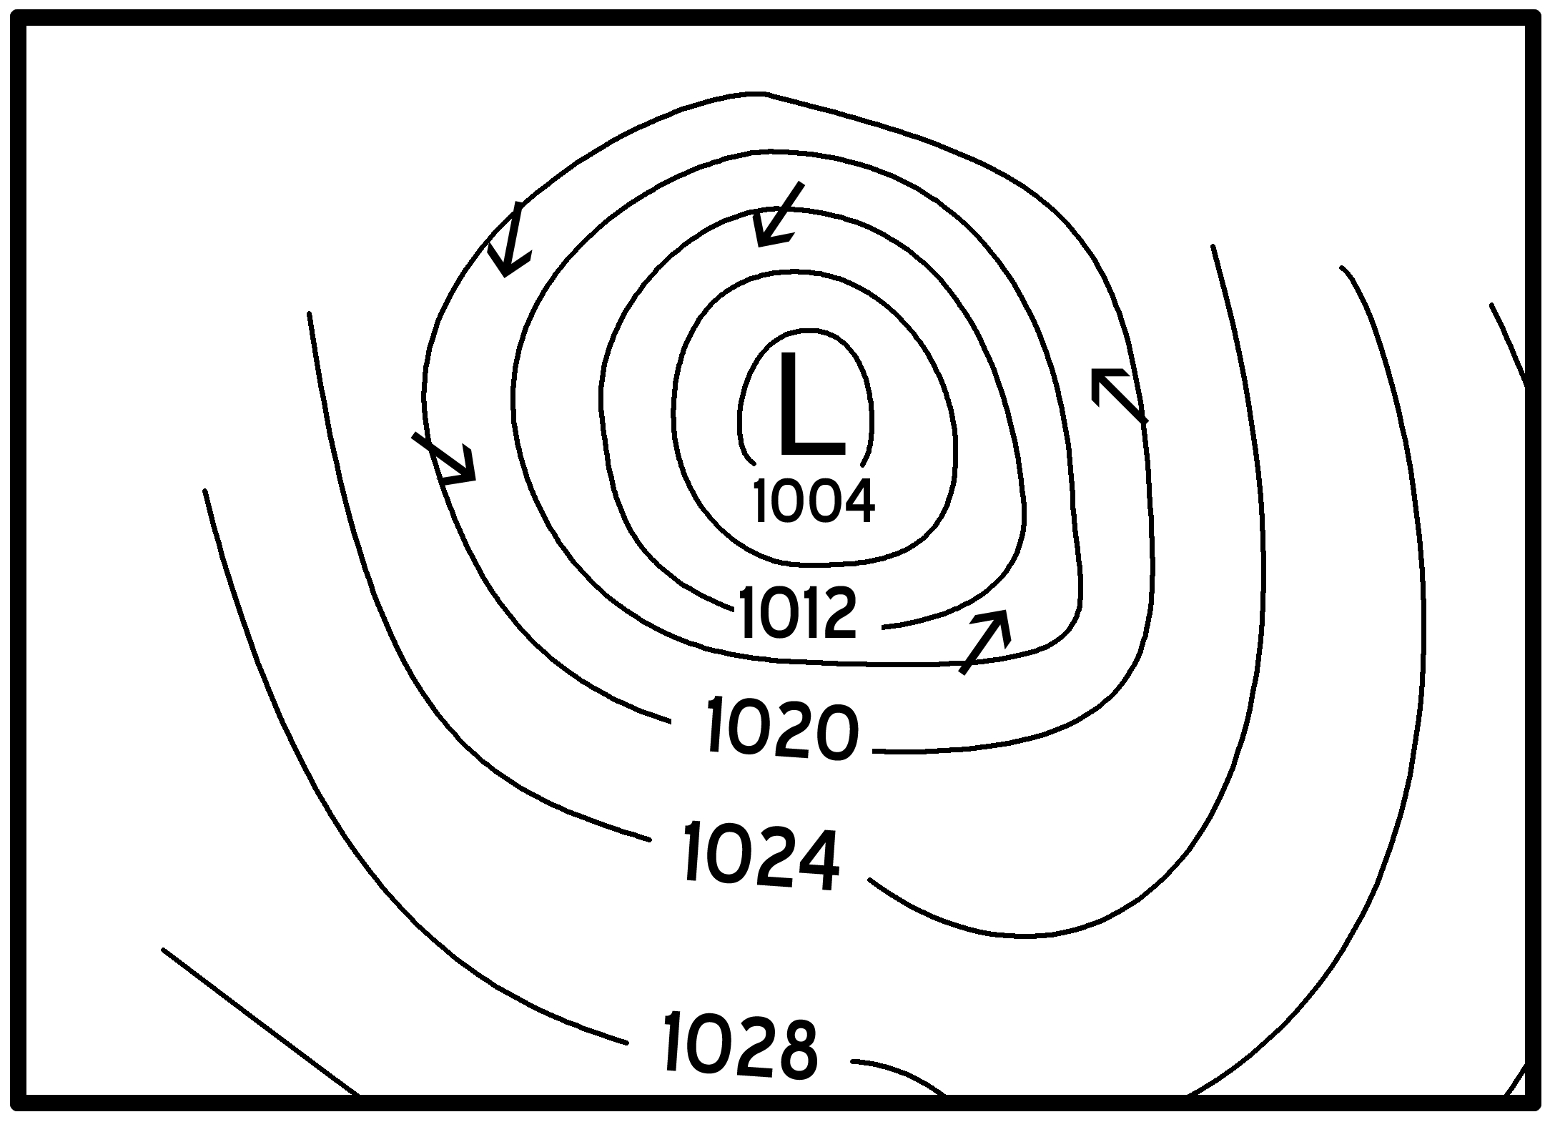
Figure 14—Schematic of surface winds associated with a typical cyclonic storm in the Northern Hemisphere. The letter, L, marks position of the surface low pressure center. Thin lines represent isobars (constant pressure contours that are labeled in millibars) at sea level. Arrows indicate the counterclockwise and inward flow of surface winds. North is at the top of the figure.

For smoke management decisions, the most important aspects of cyclones are their fronts that form and extend out from the low pressure core. A front is a boundary between two bodies of air (air masses) with contrasting properties, and is named for the conditions that it introduces. A cold front replaces warm air with colder air; a warm front replaces cold air with warmer air. A typical or ideal cyclone has a warm front extending to the east or southeast from the low center and a cold front extending to the southwest. An occluded front can sometimes form if the cold front outruns the warm front (fig. 15), pushing the warm front above the surface, and leaving the unmodified cool air at ground level ahead of the occluded front.
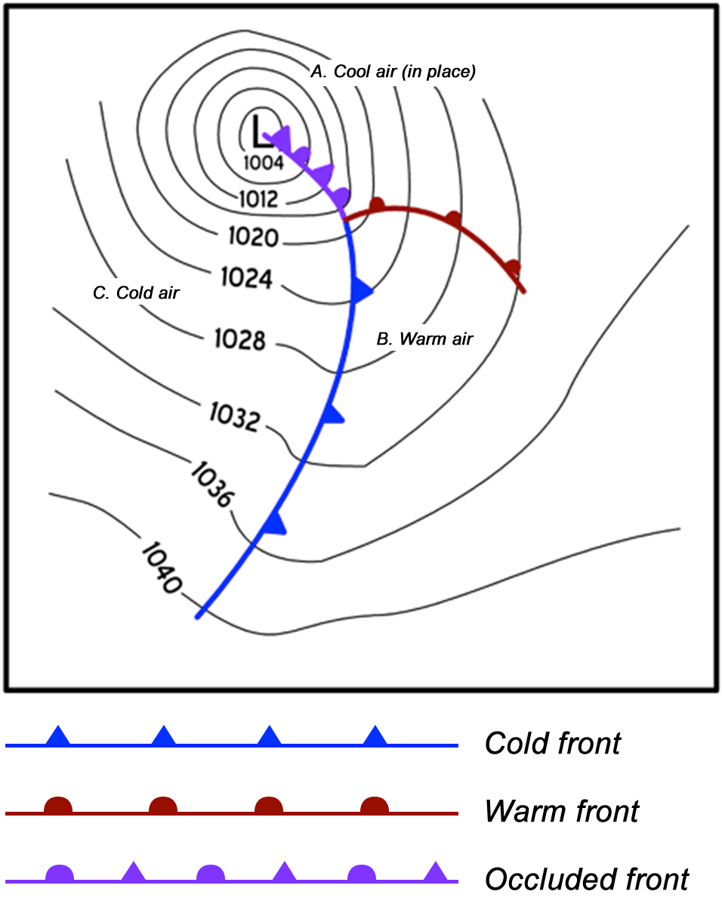
Figure 15—Schematic of temperature fronts associated with a typical cyclonic storm in the Northern Hemisphere. The letter L marks the position of the surface low pressure center. Thin lines represent isobars (constant pressure contours that are labeled in millibars) at sea level. The letter A marks the location of the cool air that is in place before any fronts pass. B marks the location of the warm air behind the warm front, and C shows the location of the cold air behind the cold front. North is at the top of the figure.

Cold fronts are typically stronger than warm fronts and have noteworthy wind effects. Winds ahead of a cold front are typically the strongest and gustiest in the entire cyclone. Passage of the cold front also brings a change in wind direction, with winds rotating clockwise as the front passes. Winds associated with a cold front tend to be stronger when the temperature contrast across the front is greater. Cold fronts also tend to be preceded by strong instability. While dispersion of smoke improves during and immediately after the cold front passes, behind the front winds weaken and stability increases. Therefore, caution must be used when planning to burn ahead of approaching cold fronts because smoke can be trapped close to the ground and disperse poorly behind the front
In contrast, warm fronts have little notable wind change. There may be a slight clockwise rotation as the warm front passes, but the more important change from a smoke management perspective is in stability. A warm front typically brings greater overall stability and an upper level inversion.
Smoke trajectories should be expected to change direction with the passage of a front, and cyclones can cause significant changes in fire behavior and resulting emission rates. Figures 14 and 15 illustrate a very simplified cyclone. In reality, the overall speed of a cyclone’s passage and the number, strength, and orientation of its associated fronts are quite variable.
At higher levels of the atmosphere, friction from the ground has less influence on the wind. This causes winds in the upper atmosphere to follow lines of constant pressure instead of blowing inward toward low pressure areas or outward from high pressure areas. In the upper atmosphere the pressure pattern of a typical storm is shaped like a trough (fig. 16). Upper air maps show the heights of a constant pressure surface, in tens of meters. For example, fig. 16 shows that the height of the 700 millibar surface increases from 2970 m to 3090 m above sea level. As air follows the height contours around the trough, southwesterly upper-level winds develop ahead of the storm, becoming westerly as the storm trough passes, and northwesterly following the trough. The upper-level trough usually trails the surface low center in moving fronts, causing smoke trajectories aloft to change directions after trajectories at the surface have changed following a storm passage. For example, before a trough axis passes, the upper-level smoke will typically be carried to the northeast, and after the trough passes the upper trajectory will shift, carrying smoke to the southeast.
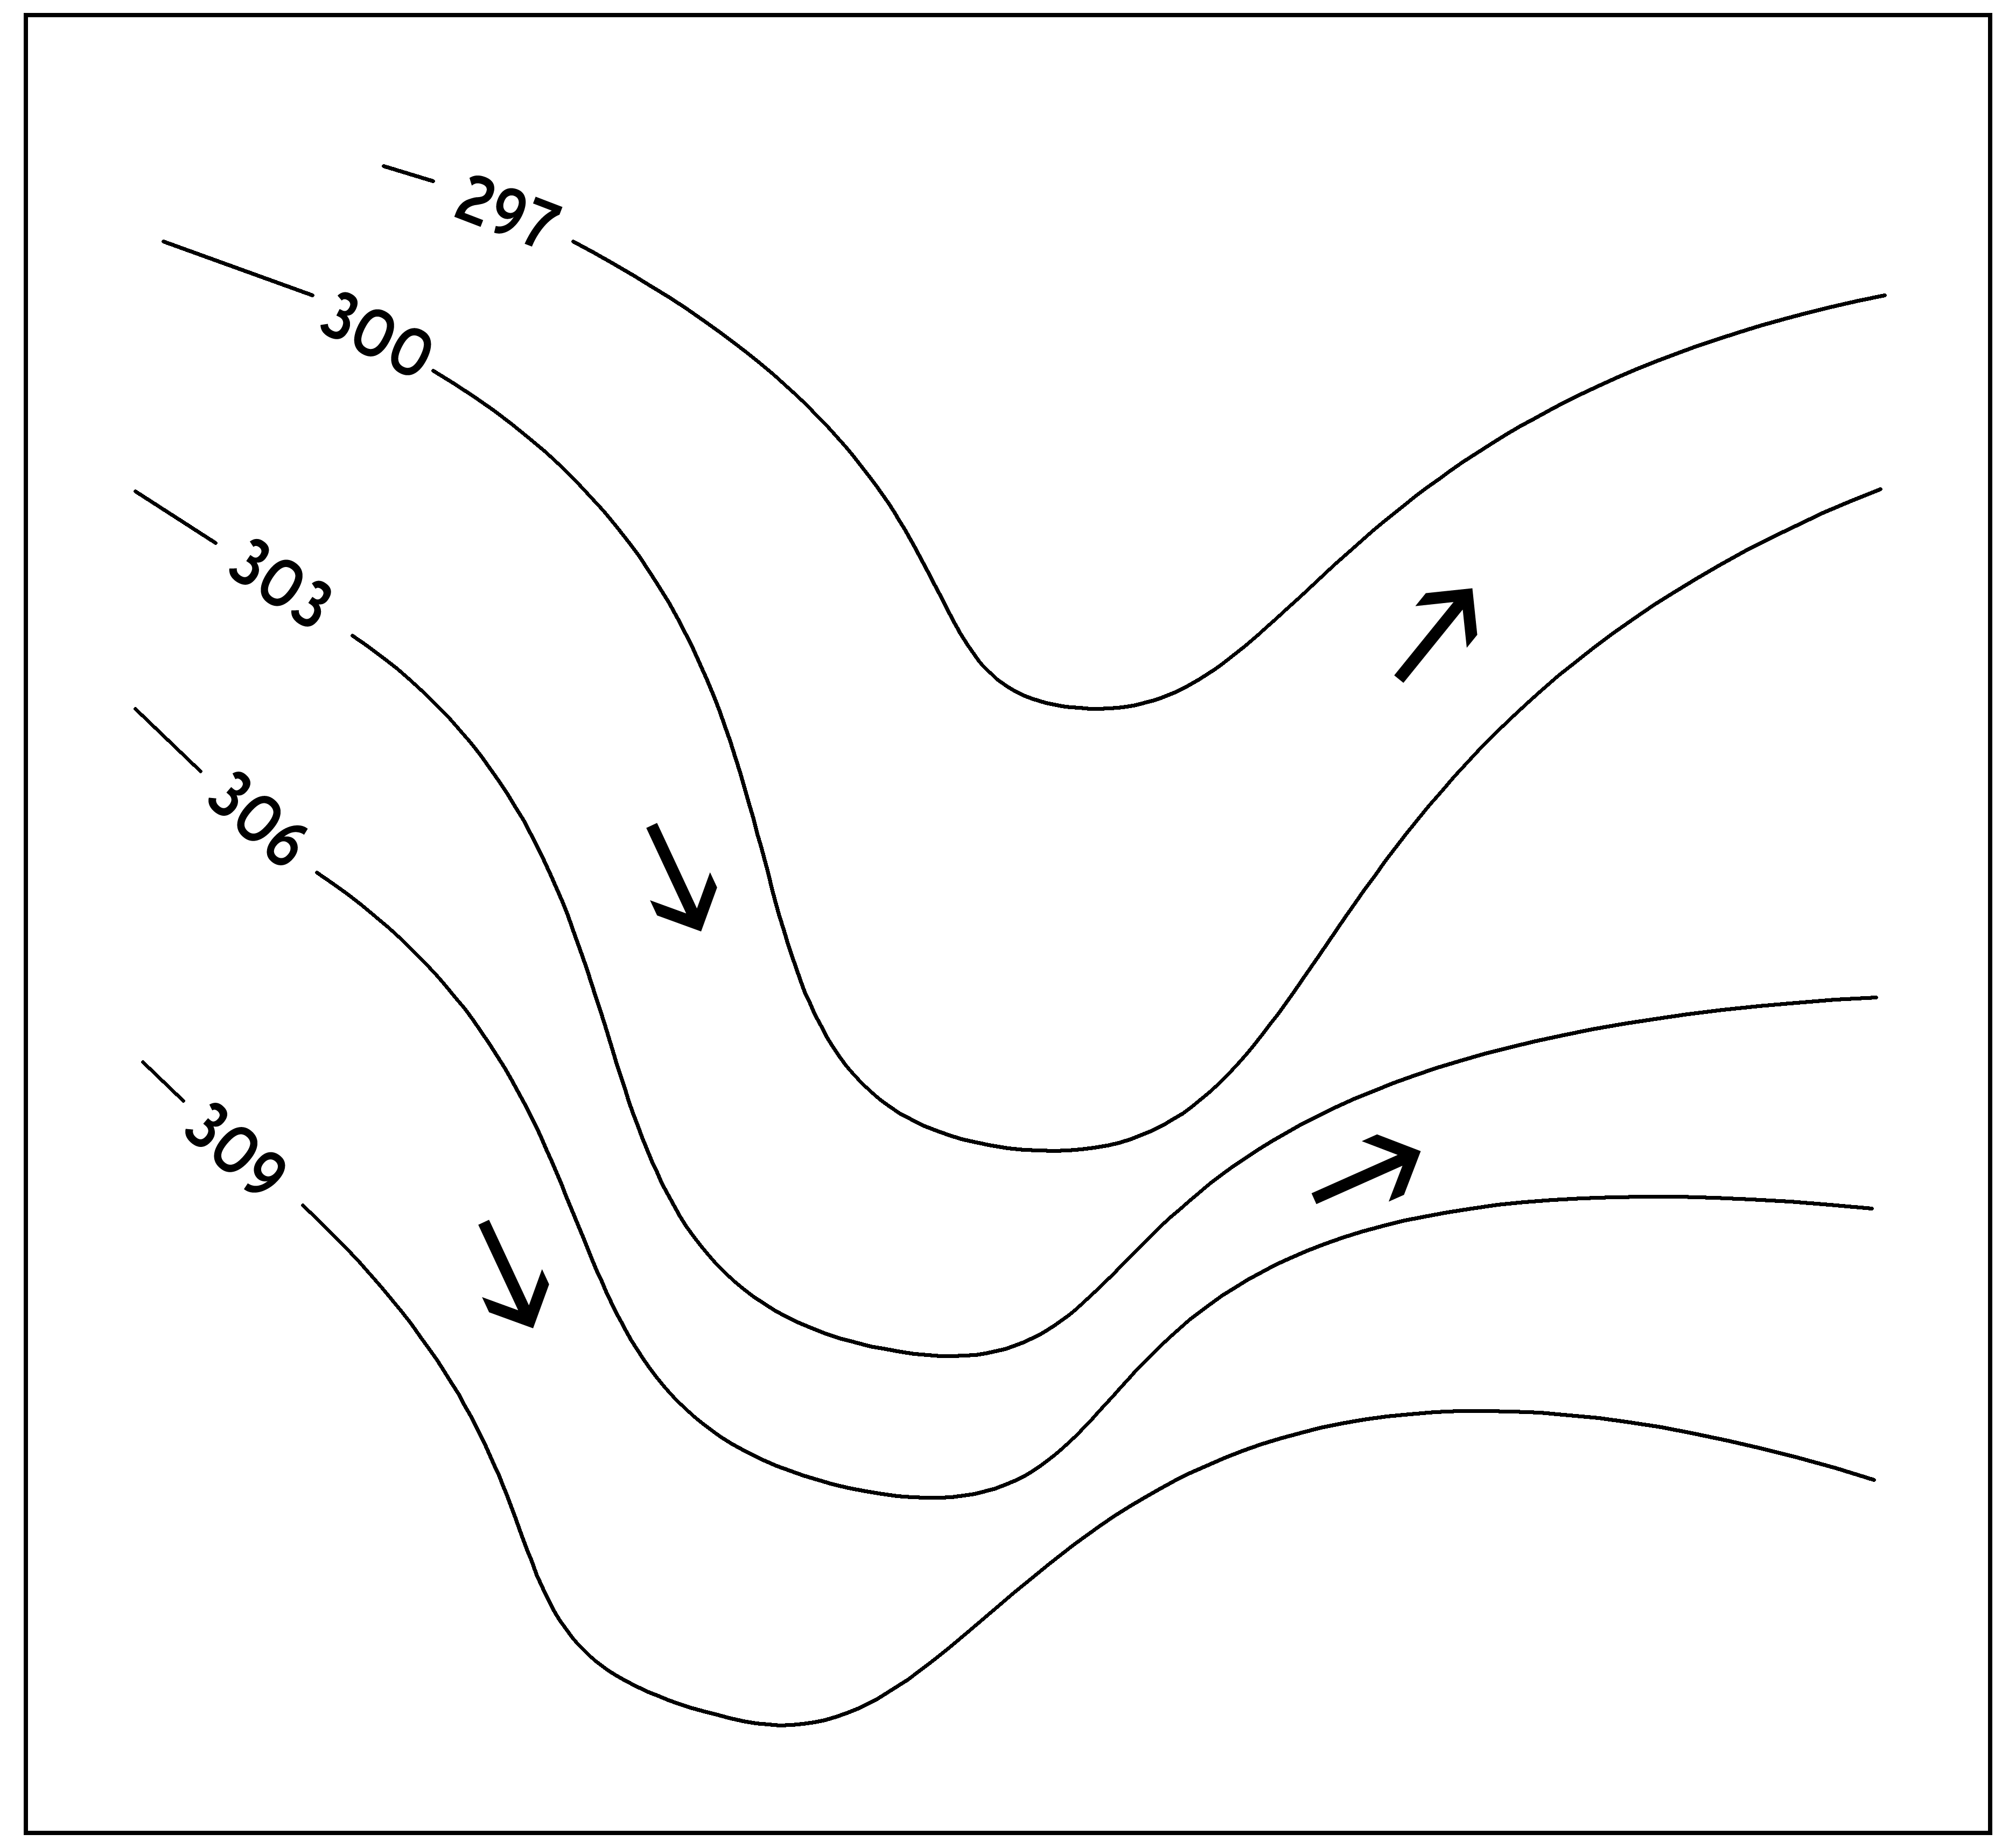
Figure 16—Schematic of upper-level (700 mb) winds associated with a typical stormy trough pattern in the Northern Hemisphere. The lines represent pressure height contours that are labeled in tens of meters (e.g., 306 represents 3060 meters and 309 represents 3090 meters). The arrows depict wind direction at those levels. South to southwest upper-level winds are common ahead of a 700 mb trough, westerly winds are common as the trough passes, and northwesterly winds are common following an upper-level trough. North is at the top of the figure.
Thunderstorms—Thunderstorms are the result of strong convection. They are typically much smaller than cyclones, tens of miles rather than hundreds of miles in horizontal extent. They create different wind patterns than cyclonic storms do. Gusty, shifting surface winds are common at times of strong convection, often reaching miles ahead or to the side of the storm itself. Although mixing heights usually are quite high during thunderstorms, allowing for well-lofted plumes, the shifting wind directions and strong gusts can cause unpredictable smoke trajectories and fire behavior near thunderstorms. Strong downbursts within the storm can produce unpredictable gusts of wind that travel tens of miles outward from the thunder cells. These sorts of gusts have created dangerous fire behavior that has been the cause of firefighter fatalities.
Diurnal winds—In the absence of strong pressure systems, fronts, or thunderstorms, diurnal wind patterns dominate trajectories of smoke near the ground. Diurnal wind patterns are caused by radiative cooling at night and solar heating during the day and the different thermal properties of land and sea surfaces that cause them to heat and cool at different rates. The differential heating causes changes in local surface pressure patterns that control air movement. Slope winds and sea and lake breezes, all of which are common in wildland smoke management situations, are typical diurnal patterns.
Downslope and upslope winds are caused by the same mechanisms that cause valley and basin inversions. When cold air from radiation cooling at night drains into a valley or basin, it causes a downslope wind. The cold air, being denser than surrounding air, usually hugs the terrain in such a way that smoke following a drainage wind will flow across the contours of the terrain. During the day, heated air from the surface rises, causing upslope winds. Because daytime heating causes more turbulence than nighttime cooling, daytime winds do not follow terrain as readily as nighttime winds, causing thermally-induced upslope winds to be less noticeable than downslope winds.
Downslope winds at night are notorious for carrying smoke into towns and across roadways (e.g., Achtemeier et al. 1998), especially where roads and bridges cross stream channels or when towns are located in valleys, basins, or near outwash plains. Downslope winds are most likely to occur when skies are clear and ambient winds are nearly calm. The speed and duration of a downslope wind is related to the strength of its associated valley inversion. Downslope winds usually begin around sunset and persist until shortly after sunrise.
Sea and lake breezes (so named because they occur near the shore of oceans and large lakes) usually occur during the afternoon when land surfaces have had a chance to heat sufficiently. The heated air rises, as if lifting the overlying column of air. This causes a region of low pressure at the surface. Because land heats more rapidly than water, the differential heating causes a pressure gradient to form. Relatively cool air remaining over a lake or ocean will flow into the low pressure formed over heated land surfaces. This cool air arrives as a front, changing temperature, humidity and wind direction as it moves inland. The sea or lake breeze not only can change smoke trajectories but incoming cool air can cause surface-based inversions that trap smoke near the ground. Strong sea breezes can bend plumes horizontally, increasing smoke concentrations near the ground.
Terrain-influenced wind—In the absence of differential diurnal heating, surface winds can also be strongly influenced by small undulations in terrain that channel, block, or accelerate air as it tries to move around or over features. For example, if ridgetop-level winds are oriented perpendicular to a terrain barrier (such as a mountain range) surface winds on the lee side of the barrier may be light and variable. They may even blow opposite to the winds at the ridge top. It is possible for strong downslope winds (such as “foehn winds” or Santa Ana winds) to develop, or for winds to be channeled through gaps in a mountain range, resulting in high wind speeds and turbulent conditions on the lee side of terrain barriers. Upper level winds oriented in the same direction as a valley can enhance or cancel up-valley or down-valley winds, depending on whether the upper level wind direction is aligned with or opposite to that of the valley winds. Upper level cross-valley winds can interact in unpredictable ways with valley winds.
The combination of wind and atmospheric stability determines whether smoke will collect on the windward side of a terrain barrier, move up, over and away, or traverse the barrier and accumulate on the leeward side. Weak winds and a stable atmosphere allow the terrain barrier to block smoke on the windward side. Strong winds in a stable atmosphere allow smoke to cross the terrain barrier and accumulate in leeward valleys and basins. Winds in an unstable atmosphere also allow smoke to cross the terrain barrier and be transported farther downwind. The height, steepness, and orientation of the terrain to the wind direction determine how strong the wind or unstable the atmosphere must be to influence smoke trajectories.
Small-scale undulations in topography can also affect smoke trajectories, especially at night when atmospheric stability keeps smoke close to the ground. Valley or drainage winds can occur under relatively stable conditions, with winds carrying smoke up-drainage during afternoon hours, and down-drainage during night and early morning hours. These may also be referred to as “canyon winds.” Gentle saddles in ridges may offer outlets for smoke from a valley. Small streambeds can collect and transport smoke even with only shallow or weak downslope winds. A simple band of trees or brush may provide enough of a barrier to block or deflect smoke. In these circumstances smoke will tend to accumulate where fog preferentially forms in the absence of smoke. As the wildland-urban interface becomes increasingly complex, the role of subtle topographic influences and surface structures becomes increasingly important.
Winds generated by these different-scaled phenomena (cyclonic storms, thunderstorms, diurnal winds, etc.) can interact with each other to affect smoke dispersion. Santa Ana winds in the Los Angeles Basin in southern California provide an example of this type of interaction. Winds around high pressure centers (also called anti-cyclones) blow in a clockwise direction deflected outward from the center of the high. When the high is located over the Great Basin (in the area around Nevada and Utah), winds blow from the NE toward southern California (fig. 17a). As the air moves toward the SW it is channeled through a gap between two mountain ranges (fig. 17b). The regional (synoptic) scale NE winds are channeled through the local scale terrain, resulting in increased surface wind speeds. The Santa Ana winds can usually occur from autumn through spring, and result in active fire behavior and winds that carry smoke offshore.
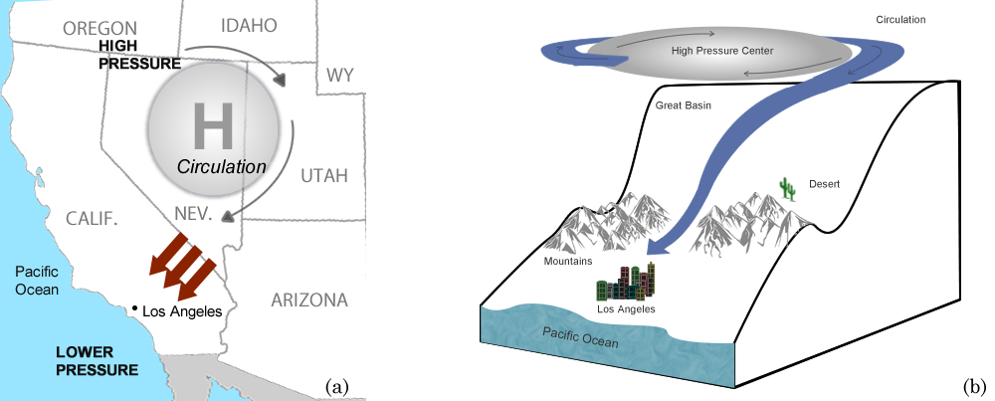
Figure 17—(a) High pressure center over the Great Basin resulting in a northeasterly wind flow into southern California (b). Northeast winds from a high pressure center over the Great Basin are channeled through gaps in the southern California mountains, generating Santa Ana winds, resulting in increased wind speeds and offshore flow.
Role of inversions on wind—Temperature inversions strongly influence wind direction and speed. Under many inversions there is little or no transport wind and smoke tends to spread out in all directions. Some inversions, such as those associated with sea breezes and valley inversions, may have significant surface wind but in a different direction to winds aloft. In these cases, smoke under the inversion may be transported in one direction while lofted smoke may move in the opposite direction. Winds above an inversion can be rather strong because the inversion separates air aloft from friction at the ground.
Wind observations—Because surface winds are strongly influenced by terrain, vegetation cover, obstacles and water bodies, it is important to know where a surface wind observation is taken in relation to the burn site. For example, observations from a bare slope near the ridgeline would not be very useful in predicting winds affecting surface smoke trajectories if most of the burn area is on a forested slope or in a valley, even if the two sites are very close. Also, if a burn site is in an east-west oriented valley and the nearest observation is in a north-south oriented valley, observed winds can be 90° different from those influencing the fire and its related smoke. Sometimes, a nearby Remote Automated Weather Station (RAWS) will be less indicative of burn-site conditions than one that is farther away if the distant station is in a location that better matches terrain at the burn site.
There are four principle sources of surface wind observations: (1) on-site measurements with a portable RAWS or hand-held anemometer, (2) observations that estimate winds using the Beaufort wind scale or wind sock, (3) local measurements with a standard RAWS, and (4) measurements from NWS observing stations. Because the surroundings of weather stations vary, from small clearings on forested slopes to open fields, and because different types of anemometers are used and mounted at different heights, wind data is very difficult to compare between one site and another. For example, observations from National Weather Service (NWS) sites use 2-minute averaged wind speed and direction, and also include gusts (the maximum instantaneous speed in the past 10 minutes) while RAWS sites use 10-minute averaged wind speed and direction. Anemometer heights at RAWS sites are sometimes different than those at NWS sites, and anemometers at RAWS sites are often affected by terrain and vegetation, while those at NWS sites are located in large clearings. Therefore, it is useful to become familiar with measurements and observations from reliable sites, and to understand local effects that make data from each site unique. Also, smoke near the ground can be transported by winds that are too light to spin the cups or propeller of an anemometer or turn its tail. Light and variable wind measurements are the result of an anemometer responding to very light winds that have a preferred direction, often influenced by surrounding topography or land use.
Because free-air winds are above the influence of topography, it is often possible to use a radiosonde observation from some point well away from the burn site to estimate upper level smoke trajectories. Also, surface RAWS mounted on the tops of ridges or mountains may compare well with free-air winds at a similar elevation. Another method to measure upper-level winds is with a pibal (pilot balloon) and theodolite. The helium-filled pibal is released and then visually tracked with the theodolite to provide a vertical profile of wind speed and direction. While pibals use old technology and do not provide information on vertical moisture and stability profiles (as do radiosondes), they are a simpler alternative to radiosondes and remain a useful smoke management tool. This equipment is not always readily available, however. If clouds are visible, upper-level wind directions can be estimated by their movement relative to the ground. High clouds look fibrous or bright white. Because the base of high clouds ranges between about 16,000 and 45,000 feet (5 km and 13 km), their movement can indicate wind at those levels. Midlevel clouds may have shades of gray or bulbous edges with bases ranging from about 6,000 to 24,000 feet (2 km to 7 km). Midlevel clouds often have a stratiform or layered appearance, which may indicate the presence of an inversion. Therefore, movement of these types of clouds may closely approximate steering winds for a rising smoke plume.
If a prescribed burn is planned for an area with unique concerns (such as proximity to populated or smoke-sensitive receptor areas), an incident meteorologist (IMET) or an air resource advisor (ARA) can be requested to help with localized weather observations and smoke forecasts. The IMET can release pibals or radiosondes to obtain upper-level winds, and their expertise can be very helpful in anticipating and predicting drainage flows and pooling of smoke in areas of complex terrain.
In addition to observations, it is becoming increasingly common to have access to data from wind models. These data do not provide the detail of a point observation in the same way that an individual site measurement does, but they do provide a broad view of wind patterns over the landscape. Standard analyses from the NWS use models to interpolate between observations. These products help illustrate upper-level wind patterns and typically are available for 850 mb, 700 mb, and 500 mb heights, either from a state, federal, or private meteorological service, or a variety of websites. For surface winds, standard NWS analyses are helpful in regions of flat or gently rolling terrain but meteorological models typically are needed to resolve surface wind fields in regions of complex topography. Local universities, research labs, state offices, and consortia of local, state, and federal agencies throughout the country are running mesoscale models (e.g., the Weather Research and Forecasting Model [WRF] [Skamarock et al. 2005], and the older fifth-generation NCAR/Penn State Mesoscale Model [MM5] [Grell et al. 1994]), producing wind maps with less than 4-km horizontal spacing. Predictions from these models usually can be found on a website through the local NWS forecast office, university, state regulator, or regional smoke manager. Also, many smoke dispersion models include wind models to generate surface winds at very fine spatial resolutions (less than 1-km grid spacing) from information on surface and upper-air observations or data from coarser meteorological models. Other “stand-alone” wind models (for example, WindNinja [Forthofer et al. 2011]) use fine-scale terrain data to generate a very-fine scale surface wind field for areas of complex terrain.

Atmospheric Moisture
Particles in the air, from smoke and other sources, may act as condensation nuclei causing water droplets to form. This can happen even if the RH is less than 100 percent. If smoke is added to an already humid environment, visibility can be severely degraded. Often a deadly combination occurs during the darkness of night when smoldering smoke drains down-valley, combined with high humidity in the cold air under a valley inversion, resulting in near-zero visibility. The effect can be fatal, especially along transportation corridors (Achtemeier et al. 1998).
Favorable conditions for fog occur when the dewpoint temperature is within a few degrees of the dry bulb temperature, wind is light or calm, and the soil is moist. Fog is most common at night when temperatures often drop to near the dew point and winds are weak. Common places for fog to form are over lakes and streams and in the vicinity of bogs and marshes.
There are times when atmospheric moisture can improve visibility, however. Smoke particles can adhere to rain droplets, causing them to be carried with the rain as it falls. This “scavenging” effect removes smoke particles out of the atmosphere, reducing smoke concentrations and improving visibility.

Weather Forecasts
Weather forecasts are typically produced twice each day and become available within 3 to 6 hours after 0000 UTC and 1200 UTC observations are complete. This is because predictive models require data from the 0000 UTC and 1200 UTC upper-air observations and a few hours of run-time on a super computer (with faster computers currently available, two additional forecasts, at 0600 UTC and 1800 UTC, are often produced). Predictive, or prognostic, models (progs) form the basis of most forecast products. For example, the first forecast of the day should be available between 0700 and 1000 local daylight time from Anchorage and between 1100 to 1400 local daylight time from Miami (subtract an hour if daylight savings time is not in effect). Earlier forecasts, or forecasts updated throughout the day, are possible if the most recently available upper-air observations and prognostic model results are combined with updated surface observations. While public forecasts issued by the NWS and the media are useful, they typically lack the detail needed for smoke management. For this reason, spot-weather forecasts may be requested from state, federal, or private weather services that provide predictions of critical variables that influence smoke at specific times and locations.
Even though there are more and more numerical guidance tools, weather forecasting is still an art, especially in places with few observations or where there are complex local interactions with terrain, water bodies, and vegetation cover. The primary source of smoke weather forecasts remains the NWS. Their rigorous training, fire weather program, and state-of-the art equipment and analysis tools help maintain a unique expertise. All NWS forecast office websites include a fire weather forecast page, most of which include special smoke management forecasts or fire weather planning forecasts that contain smoke dispersion indices. In addition to NWS forecasters, highly-skilled meteorologists can be found in any one of the many states which have a smoke management program. Also, the number of interagency fire weather offices and private meteorological services is growing and can provide reliable forecast products specifically designed for managing smoke. Whatever the source of a forecast, it is helpful to combine the forecast with your own general understanding of weather conditions by reviewing the many satellite pictures, current observation summaries, onsite field observations, and prognostic model results now available on the Internet. In this way, apparent trends and local influences can be determined and quick changes in smoke management strategy can be made. For example, increasing afternoon cloudiness in the forecast may have indicated an approaching storm predicted for the following morning. If clouds did not increase when predicted, however, it could be suspected that the storm has been delayed or it was diverted elsewhere. A check with the forecaster or updated satellite picture may confirm the suspicion and the management plan may be altered.
Because the atmosphere behaves chaotically, the accuracy of a weather forecast improves the closer you get to your planned burn. For example, it is possible to obtain an indication of storminess within 30 to 90 days in advance of a burn. A storm passage, however, may not be predicted until about 14 days in advance, and with about 2 days accuracy. Within 5 days, 1-day accuracy on storm passage may be possible. Increasing accuracy should be expected within 48 hours, and the timing of storm passage within 1/2 hour may be possible with 12 hours advance notice. Spot weather forecasts are usually requested the day of the burn, but usually are available 24 hours in advance of a scheduled burn. Each NWS office provides online forms for requesting spot forecasts.
Our increasing knowledge of air-sea interactions is making it possible to predict some general weather patterns several months in advance based on historical impacts. For example, weather in some (but not all) regions of the country responds to the El Niño/Southern Oscillation (ENSO). Precipitation and temperature during winter and spring are very strongly related to ENSO. For example, drier than normal conditions over the course of a winter season may be associated with El Niño events; however, this doesn’t mean there will be drought conditions during every El Niño event, and large rainstorms are possible. Relating the key factors for smoke management such as wind, mixing height, and stability to ENSO is more difficult, especially during summer. Nevertheless, an ENSO-based seasonal prediction gives prescribed fire practitioners an idea of general weather conditions to be expected, thereby helping prioritize scheduled burns and decide if marginal days or weekends early in the burning season should be used or whether a more optimum season will ensue.

Climate
Climate simply describes the weather patterns that prevail in an area over many years. Understanding climate patterns can help develop long-range smoke management plans or adapt short-range plans. For example, afternoon mixing heights in most coastal regions of the United States are typically lower than those in the interior because moist marine air is relatively stable. This means that there may be fewer days with optimum dispersion along the coast than interior. It usually is windier along the coast, however, and burns might be scheduled in the early morning if offshore breezes are preferred to reduce smoke effects on cities and towns.
It is possible to infer climate just by local proximity to oceans, lakes, rivers, and mountains, as depicted by the Koppen climate classification (Peel et al. 2007). Also, vegetation cover can give an indication of climate. Desert landscapes, with a lot of bare soil or sand, heat and cool rapidly, causing them typically to have high daytime mixing heights and very low nighttime mixing heights. Natural landscapes of lush green forests tend to absorb sunlight while releasing moisture, both of which modify heating and cooling of the air close to the ground surface. This can reduce daytime mixing heights and keep nighttime heights relatively high in comparison to drier landscapes. Also, the structure of trees, where the direction of branches or flagging point away from prevailing wind directions often indicates persistent high winds.
Quantitative summaries of climate can be obtained from the state climate office or regional climate center, many of which also maintain informative Internet sites and can be reached through the National Climatic Data Center (NCDC) (www.ncdc.noaa.gov). It is very common to find temperature and precipitation data in climate summaries. Monthly or annual averages or extremes are readily available, while climate summaries of daily data are just beginning to emerge. For example, a climate database (Ventilation Climate Information System [VCIS] Ferguson et al. 2003) provides information on twice-daily variations in surface wind, mixing height, and ventilation index over a 30-year period. The wind speed and direction are presented as “wind roses.” Wind roses (fig. 18) are polar plots that simultaneously display wind speed, wind direction, and relative frequency. Other features common to wind roses are:
- The percentage of calm winds (<1 m/s) is shown in the lower right corner of each wind rose graph.
- Wind speeds are represented by line thickness and color. Higher wind speeds are indicated by thicker lines and are light to dark green in color.
- The direction that the wind comes from is represented by the angle in which a ray radiates out from the center of the plot. Straight up indicates winds coming from true north.
- Wind frequency is indicated by the length of each line segment of a given thickness and direction. The numerical labels on the concentric circles provide a scale for each graph.
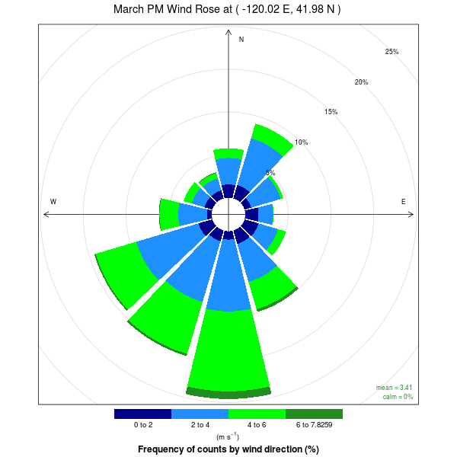
Figure 18—Wind rose summarizing 30 years of wind speed and direction data for afternoon hours in March, at 41.98N, 120.02W from VCIS.

There are year-to-year variations in climate (e.g., ENSO) so at least 10 years of weather data are needed to obtain a preliminary view of climate in a particular area. There also are natural “decadal” patterns in climate that last from 7 to 20 years. Therefore, it is appropriate to analyze 30 to 50 years of weather observation data for any reliable climate summary.

Summary
Managing smoke—from single burns or multiple burns occurring simultaneously—in ways that prevent serious effects on smoke-sensitive areas requires knowledge of the weather conditions that will affect smoke emissions, trajectories, and dispersion. Not only is it necessary to anticipate the weather ahead of time through the use of climatology and forecasts, but it also is useful to monitor conditions before and during the burn with regional forecasts, local forecasts, and on-site observations. On-site observations are helpful because air movement, and therefore smoke movement, is influenced by subtle variations in terrain and vegetation cover, and distance to large bodies of water, which off-site observations usually cannot capture. Also, forecasts are not always accurate and last-minute changes in a burn or smoke management plan may be needed. To gain more insight into the physical process of weather in wildlands and its effect on biomass fires, refer to what is commonly called the fire weather handbook (Schroeder and Buck 1970).
In using weather observations, forecasts, and climate summaries effectively for smoke management there are three general guidelines: (1) become familiar with local terrain features that influence weather patterns, (2) develop a dialogue with a reliable local weather forecaster, and (3) ask for and use climate summaries of wind and mixing height. By combining your knowledge of local weather effects, trust and communication with an experienced forecaster, and understanding of climate patterns, it is possible to fine-tune or update forecasts to meet your specific smoke management goals.

English Equivalents—
When you know: Multiply by: To get:
Millibars (mb) 0.02953 Inches of mercury
Meters (m) 3.28 Feet (ft.)
Kilometers (km) 0.621 Miles
Hectares (ha) 2.47 Acres
Meters per sec (m/s) 2.24 Miles per hour
Meters per sec (m/s) 1.94 Knots

List of Abbreviations

DALR Dry diabatic lapse rate
ENSO El Nino-Southern Oscillation
IMET Incident meteorologist
MALR Moist (or saturated) adiabatic lapse rate
MM5 Fifth-Generation NCAR / Penn State Mesoscale Model
NCDC National Climatic Data Center
NWS National Weather Service
PBL Planetary boundary layer
Pibal Pilot balloon
Raob Radiosonde observation
RAWS Remote automated weather station
SALR Saturated (or moist) adiabatic lapse rate
UTC Universal Time Coordinated
WRF Weather Research and Forecasting Model

Literature Cited
Achtemeier, G.L.; Jackson, W.; Hawkins, B.; Wade, D.D.; McMahon, C.K. 1998. The smoke dilemma: a head-on collision! In: Wadsworth, Kelly G., ed. Transactions of the 63rd North American Wildlife and Natural Resources conference; 1998 March 20-25; Orlando, FL. Washington, DC: Wildlife Management Institute: 415–421.

Ferguson, S.A.; McKay, S.; Nagel, D.; Piepho, T.; Rorig, M.L.; Anderson, C.; Kellogg, L. 2003. Assessing values of air quality and visibility at risk from wildland fires. Research Paper PNW-RP-550. Portland, OR: U.S. Department of Agriculture, Forest Service, Pacific Northwest Research Station. 59 p.

Forthofer, J.M.; Shannon, K.S.; Butler, B.W. 2011. Initialization of high resolution surface wind simulations using NWS gridded data. In: Proceedings: 3rd Fire Behavior and Fuels Conference. Birmingham, AL: International Association of Wildland Fire: [pages unknown].
http://www.fs.fed.us/rm/pubs_other/rmrs_2010_forthofer_j001.pdf. (14 January 2016)

Grell G.A.; Dudhia, J.; Stauffer, D.R. 1994. A description of the fifth- generation Penn State/NCAR Mesoscale Model (MM5). Mesoscale and Microscale Meteorology Division, National Center for Atmospheric Research NCAR Technical Note NCAR/TN-398+STR. 121 p.

Holzworth, G.C. 1972. Mixing heights, wind speeds and potential for urban air pollution throughout the contiguous United States. Office of Air Programs Publication No. AP-101. Research Triangle Park, NC: Environmental Protection Agency. 118 p.

Lavdas, L.G. 1986. An atmospheric dispersion index for prescribed burning. Research Paper SE-256. Dry Branch, GA: U.S. Department of Agriculture, Forest Service, Southeastern Forest Experiment Station. 35 p.

Lavdas, L.G. 1997. Estimating stability class in the field. Research Note SRS-4. Asheville, NC: U.S. Department of Agriculture, Forest Service, Southeastern Forest Experiment Station. 2 p.

Pasquill, F. 1961. The estimation of the dispersion of windborne material. Meteorological Magazine. 90: 33–49.

Pasquill, F. 1974. Atmospheric diffusion: the dispersion of windborne material from industrial and other sources. 2nd edition. New York: Halsted Press. 429 p.

Peel M.C.; Finlayson B.L.; McMahon T.A. 2007. Updated world map of the Köppen-Geiger climate classification. Hydrology and Earth Systems Science. 11: 1633−164.

Schroeder, M.J.; Buck, C.C. 1970. Fire weather: a guide for application of meteorological information to forest fire control operations. Handbook 360. Washington, DC: U.S. Department of Agriculture, Forest Service. 229 p. http://gacc.nifc.gov/nwcc/content/products/intelligence/Fire_Weather_Agriculture_Handbook_360.pdf. (19 January 2016).

Skamarock, W.C.; Klemp, J.B.; Dudhia, J.; Gill, D.O.; Barker, D.M.; Wang, W.; and Powers, J.G. 2005. A description of the advanced research WRF version 2. NCAR Tech. Note NCAR/TN-468+STR, 88 pp.

U.S. Department of Commerce, National Oceanographic and Atmospheric Administration, National Weather Service. 2009. Glossary. http://w1.weather.gov/glossary/. (22 April 2015).

This is for dry air. Moisture complicates matters, and is discussed later.
The terms fanning, looping, lofting, coning, and fumigating have previously been applied to smoke plumes from wildland fires. These were borrowed from urban air pollution usage, and are not particularly suited to smoke produced at the ground. These terms may be encountered in other literature; however they will not be used here.
There are no winds on this blank skew-T because there are no data plotted. See fig. 7 for an example with plotted winds.
UTC stands for Universal Time Coordinated, sometimes called “Zulu time.”
The Beaufort wind scale estimates wind speed using observations of wind-effects in the landscape. For example, wind speeds of 1.6 to 3.3 m/s (4 to 7 mph) will cause leaves to rustle slightly. If leaves move around vigorously then the wind speed is approximately 3.4 to 5.4 m/s (8 to 12 mph). The Beaufort wind scale can be found at http://www.crh.noaa.gov/images/iwx/publications/Beaufort_Wind_Chart.pdf (or by internet search).
Wind socks continue to be used at airports and are useful if trying to monitor winds on a nearby ridge that is visible.
Available online at www.smoke.airfire.org/vcis.

